Land Use Committee
August 9, 2005
Minutes
Call to Order: 7:02 pm by Chm Larry Daniels

Announcements:
- Conduct of Meeting:
  - Roberts Rules, informal committee of the whole to extent possible but please go through Chair to speak
  - Time limits, if necessary
- Upcoming meeting dates, events & misc. announcements
  - Community interest items on last pages of agenda
    - Hazardous Forest Fuel Treatment/ Habitat Enhancement Demo
    - Weatherization Assistance Memo – PO Bulletin Board
    - MOA Casting Call
    - PO Bulletin Board – about three weeks
  - 8/15 GBOS
  - 8/17 Federation of Community Councils – go to web site for more info
    - http:communitycouncils.org
  - 8/22 Public Hearing on Chapter 9 – Location to be determined. Be prepared to express your concerns specifically, they want details, not generalizations.
  - 9/6 Trails Committee
  - 9/13 LUC
- Agenda Item LUC 050804 moved to first item to be considered due to Joe Wolner time constraints. No objections.

Agenda Item LUC 0508-01: Officer Reports & LUC comments and actions as necessary.
- Chairman’s report
  - Chapter 9 update & status
    - Joint Assembly meeting Aug 4th at hotel – Larry gave a brief synopsis of the workshop/meeting.
- Vice-Chairman’s report
  - None
- Secretary report
  - Approval of 7/12/05 LUC meeting minutes –
    - 1) Ellen Twiname 2) John Gallup; Approved as published Yea 10, Nay 0, Abstain 0

- Agenda Item LUC 0508-02: Committee reports; None

- Agenda Item LUC 0506-03: (Case number 2005-082) Hearing Date: Monday, Jul 11, 2005; Petitioner: Tim Cabana; Request Detail: A conditional use for parking calculations, landscaping and sign regulations for a hotel. Alpine View Estates Phase 1, Tract A-2C. Located on the south side of the Alyeska Highway, west of Timberline Drive in Girdwood; Legal Desc.: R-11 Turnagain Arm district; Site Address: NHN KAMI WAY. For further information, refer to Agenda Item LUC 0505-10 (Case Number not available) Tim Cabana Project - 50 room hotel on Donner.
Although a case number was not available at the time the LUC took with the following action at the May 10, 2005 meeting:
Motion: Non-objection to the hotel and shops as presented by Tim Cabana.
1) Barry Kircher 2) Chris Von Imhof Passed (Yea 40; Nay 0; Abstain 6)
Although no representative was in attendance to present this case, action taken by the LUC at the June 14th meeting was:
Motion: Pass on to GBOS for their action with no recommendation from LUC.
1) John Gallup 2) Kevin McDermott Passed: (Yea 8; Nay 0, Abstain 3)

This matter may have already been completed but is being included in the agenda in case it needs to be considered again by the LUC. The petitioner need not be present unless further action is desired. Action will be taken as deemed appropriate by the LUC.
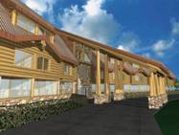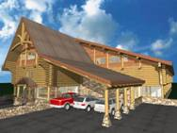
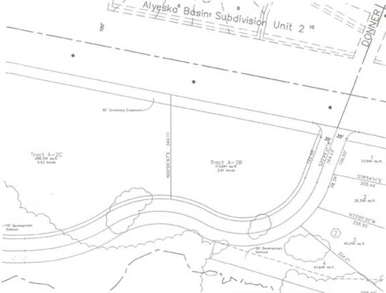

No action taken on this item due to no representative or information available.

- Agenda Item LUC 0507-05: (Case number 2005-108) Hearing Date: Monday, Sep 12, 2005; Petitioner: Per Bjorn-Roli, PO Box 110903, Anchorage, AK 99511, E-Mail: perbjornroli@aol.com; Request: A conditional use to allow a 12-plex multiple family residential structure in the R-11 zoning district. Alyeska Subdivision, Block 6A, Lot 11A (Now platted as Lot 11B). Located on Garmisch Drive; R-11 Turnagain Arm district.
Reference previous agenda item LUC 0505-09 Platting Case S11375-1 Per Bjorn-Roli To subdivide two lots into two different lots. East of Alyeska Avenue and south of Garmisch Road. Alyeska Subdivision, Block 6A, Lot H1A & I1A, located within the NW1/4 of Section 16, T10N, R2E, S.M., Alaska. Fred Walatka & Associates (Hearing date 5/30/05)
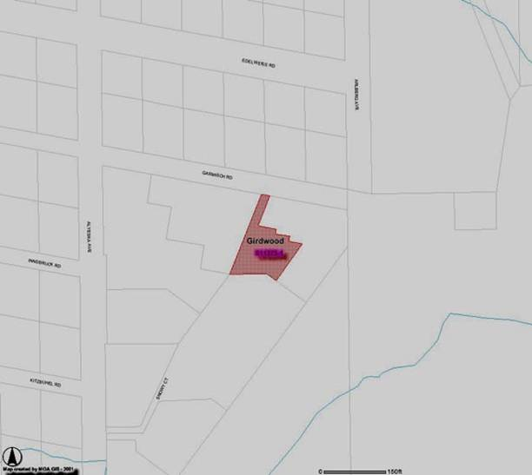

Yvonne Safar, General Contractor for the project, briefed those present on the project followed by a question and answer period.
- There will be four buildings, each with three units
- Varied in size from 1200 sq. ft. to 2100 sq. ft.
- Building coverage approximately 25 % of lot (40% allowed)
- Meets height and set back criteria
- Will be landscaped for summer and winter
- Road and driveways will be heated so no snow removal needed – no water runoff
- Existing condos on both sides
- George McCoy will be exclusive agent
- Projected schedule
  - Site work in 2005
  - 2 buildings completed in 2006 – maybe more depending on sales
- Will be first class project
After several attendees complimented Per and Yvonne on the project, the LUC action was to pass a resolution of non-objection to the project as briefed by Safar and Per Bjorn Roli. 1) John Gallup 2) Diana Livingston; Passed Yea 17, Nay 0, Abstain 0

- Agenda Item LUC 0508-03: Diana Livingston
A RESOLUTION OF THE GIRDWOOD BOARD OF SUPERVISORS Land Use Committee SUPPORTING ESTABLISHMENT OF A GIRDWOOD MUSEUM IN THE HISTORIC ROUNDHOUSE BUILDING.
WHEREAS, the community that became Girdwood traces its beginnings to the discovery of gold in the late 19th century and took its name from an early miner, and
WHEREAS, Girdwood is the northwest boundary of the nation’s second largest national forest established by President Theodore Roosevelt in 1907 to protect the region’s natural resources from further exploitation by the Alaska Syndicate, and
WHEREAS, documents were first filed fifty years ago in 1955 to acquire land in Girdwood for a ski resort, and
WHEREAS, the Alyeska Roundhouse was constructed in 1960 as the terminus to the first chairlift, and
WHEREAS, the Alyeska Roundhouse was placed on the National Register of Historic Places in 2003 and efforts began to raise funds to renovate the Roundhouse and establish a museum to commemorate and preserve Girdwood’s unique history, and
WHEREAS, funding has been substantially established to insure the completion of this project, along with agreements for perpetuating the maintenance, operation and staffing of the Roundhouse Museum, with no liability to the Girdwood Community, now, therefore,
BE IT RESOLVED that the Girdwood Board of Supervisors Land Use Committee supports the project to renovate the Alyeska Roundhouse and develop a museum dedicated to preserving Girdwood’s history.
PASSED AND APPROVED BY THE GIRDWOOD BOARD OF SUPERVISORS Land Use Committee ON August 9, 2005. 1) Per Bjorn Roli 2) John Gallup; (Yea: 17, Nay: 0, Abstain: )

- Agenda Item LUC 0508-04: Joseph Wolner, Girdwood, AK - Request for a resolution of support for the Girdwood Playground Committee plans. The Girdwood Playground Committee was formed to undertake the renovation of the Community Park known as Little Bears Playground located at the corner of Alyeska Highway and Hightower Road, Girdwood, Alaska. Our purpose is to create a safe and fun playground that reflects the spirit, artistry, and imagination of our community. The goal is to guarantee a playground that meets safety standards with accessibility for all children.
Concerned parents along with Anchorage Parks and Recreation formed this Committee to define the plans for installing a safe, environmentally sound, accessible playground. Also to begin a fund-raising drive to reach our goal of renovating the playground.
The Committee's campaign goal is to reach $100,000 and to complete the playground project in the summer of 2006.
Forest Fair is our current Fiscal Sponsor. This means that all donations will go through the Forest Fair into an account for the Playground Renovation. We chose a Fiscal Sponsor rather than applying for non-profit status on our own due to the short period that this project will take. Also being that the Forest Fair Park is connected to the playground, it was a perfect fit. The Forest Fair set us up to run the Root Beer Garden this year and we Grossed $2400 (not a bad start).
By vote in February 2005 our committee decided to go with a Leathers and Associates design. http://www.leathersassociates.com/
This type of design will allow for a unique structure that will reflect the Girdwood Community. There are 3 playgrounds in Alaska designed by Leathers (Wasilla, Palmer, and Haines. http://hainesak.com/playground/).
Those who have seen their playgrounds agree that it would blend with Girdwood's character. The design is based on community input before and during the Design Day. The Design Day is really a kick-off event that gets the community jazzed about the project and incorporates the ideas and input of the children, artisans, and the community as a whole.
According to Robin Ward of HLB: "I did some checking and found out that it is city land managed by Parks and Rec. Chad should be able to answer your questions, but if you need any help, please don't hesitate to call me." I'll be presenting and have pictures available of Leathers projects. If something comes up I'll be sure to have a representative in my place.
We are very excited about the project!
Please let me know if you need any additional information.
- Joe Wolner briefed those present on the needs and projected schedule. After a question and answer period, the LUC passed the following resolution.
- Be It Resolved that the Land Use Committee supports the project to renovate the Little Bears Playground.
1) John Gallup 2) Diana Livingston; (Yea: 13, Nay: 0, Abstain: 0)

The meeting was adjourned at 7:42 pm.

** End of minutes **
The above may be viewed on the Federation of Community Councils Girdwood web page at http://communitycouncils.org/girdwood/girdwood.html. Additional information will be posted there as it is received.

If you would like to receive Land Use Committee information and notification of meetings by email, please email me at Ron@Burson.org with your request.

*****************************************
Miscellaneous Information and Communications Received

From: Community Councils [councils@ak.net]
Sent: Monday, June 27, 2005 8:08 AM
Subject: FW: Anchorage Woodlot Hours

The wood disposal lot hours have been extended, at least for the south Anchorage lot at C and Minnesota. This is an important development because the hours have been very short this season.

The Anchorage Soil & Water Conservation District has extended the hours of operation of the Anchorage Woodlot effective immediately. The new hours are as follows:

Monday through Thursday 9am - 8pm
Friday through Sunday 10am - 6pm

For more information, go to http://www.muni.org/fire1/Woodlots.cfm

Thank you,
Ryan Stencel
Operations Manager
Anchorage Soil & Water Conservation District

Additional information:
Municipal Wood Lots are for the disposal of wood and brush by private homeowners. No stumps, garbage, metal, or construction materials will be allowed. There is no charge for disposal at either the Anchorage or Eagle River Wood Lots.

For garden wastes:
Anchorage Regional Composting Facility
Contact: Pete Kineen 243-8577

Accept wood of any kind, leaves, brush, grass, stable waste.
7895 West End Rd, 3.7 mi. west of Northern Lights Blvd. and Postmark Rd.

Nominal fee charged.

*****************

August 2, 2005
Subject: Hazardous Forest Fuel Treatment/ Habitat Enhancement Demo.
Attn: Demonstration Invitees:
The Alaska Moose Federation and Alaska Village Initiatives would like to invite
you and all persons interested to a demonstration of new forest treatment
technology and techniques. The new machines being used are designed to be
easy on the land with low ground pressure, eliminating the risk of a catastrophic
wildfire while returning forests to healthy, natural states.
The key reason for our involvement with these forest practices, while rebuilding
the health of our forests, is that they will create better wintering habitat for
Alaska’s moose. Rising vehicle and railroad collisions with moose is as
unacceptable as increasing hazardous moose occurrences on school grounds
and in neighborhoods. As community development continues within moose
habitat, areas away from the communities must be treated to encourage moose
off of our roads and away from schools and neighborhoods. Current conditions
of severe catastrophic fire danger threatens many Alaskans throughout the state.
Let us take control of our safety within this wildland urban interface and quit living
with fear from hazardous wildfire and increasing moose collisions on our
highways.
Please consider witnessing this demonstration to turn our insect and disease
infected forest stands next to our communities into healthy pioneer forests we all
can use and enjoy for future generations. Bring your raingear, walking shoes
and bug dope with a n open mind to see the latest developments in forest
management in other states and countries which face similar hazards of
catastrophic wildfire have embraced this protocol to help the forests we all live in
and cherish.
Please RSVP via e-mail golson@growmoremoose.org or 336-6673 for this event.
Sincerely,
Gary Olson, Chairman Charles Parker, Director
Alaska Moose Federation Alaska Village Initiatives
Phone: (907) 336-6673 Phone: (907) 274-5400 ext. 846
golson@growmoremoose.org cparker@akvillage.com
Event: Hazardous Fuel Treatment/ Habitat Enhancement Demonstration
Date: August 10, 2005
Time: 9:00 a.m. - 1:00 p.m.
Where: Meeting will begin at the Alaska Moose Center (Tanglewood Lakes
Lodge) at 11701 Brayton Drive. Our headquarters is located on the
frontage road next to the indoor golf driving dome at Huffman &
New Seward Highway.
Demonstration location will be approximately 4 miles above Potters
Marsh on a private land owner's property.
9:30 a.m. Bus leaves headquarters to homestead.
10:00 a.m. Demonstration begins.
10:20 a.m. Review and explanation of treated area.
10:50 a.m. Bus returns to headquarters.
11:20 a.m. Arrive at headquarters, refreshments upstairs.
11:30 a.m. Supertrak’s presentation.
11:40 a.m. NPI, LLC presentation.
11:55 a.m. Alaska Moose Federation/ Alaska Village Initiatives
presentation, questions and answers.
12:00 p.m. Lunch and open discussion.
Equipment being demonstrated: http://www.supertrak.com/tl150.htm
http://www.supertrak.com/sk120tr.htm

***********************
WOULD YOU LIKE TO BE AN ACTOR?
SPEND AUGUST 18TH AT KINCAID PARK?
HERE’S YOUR CHANCE TO PROVIDE A SERVICE,
SPEND A DAY OUTDOORS AND HAVE FUN!
We’re looking for 150 volunteers willing to be “victims for a day”
Thursday, August 18 at Kincaid Park from 9:30am until 3:30pm!
Volunteers will play victims of a major disaster in Anchorage.
Specific roles and injuries will be assigned at the park.
“Injuries” (created from makeup and latex) will range from cuts and
bruises to broken limbs and major injuries – even some fatalities.
(All simulated, of course!)
Some “victims” will be treated on site, others will be transported
to local hospitals. (All volunteers will be returned to Kincaid
before the end of the exercise!)
We need people willing to give 5 to 6 hours of their time!
We need volunteers of all ages – adults and children!
A great opportunity for service clubs, scout troops or anyone interested.
Please join us! With your help, our community will be better prepared
to face real emergencies in the future!
If you would like to be part of this event, please contact the
MOA Office of Emergency Management
at 343-1404 or moranme@muni.org.

