Land Use Committee
April 12, 2005
Minutes (DRAFT)

Call to Order: 7:05 PM – Total of 74 people signed in

Announcements: Larry Daniels
- Conduct of Meeting: Roberts Rules, modified as needed
- Crow Creek Neighborhood Plan - There is a meeting coming up sometime in the next month, but we don’t yet know when.
- Other upcoming meeting dates
  - 5/16 GBOS
  - 5/18 Federation of Community Councils at City Hall
  - 6/7 Trails Committee
  - 6/14 LUC
  - 6/15 Federation of Community councils at City hall
  - 6/20 GBOS

Late Agenda Item: Tim Cabana project added – NO OBJECTION

Agenda Item LUC 0505-01: Officer Reports & LUC comments and actions as necessary.
- Chairman’s report
  - Order of Business: Changed LUC 0505-11 to before LUC 0505-10 to accommodate John McPherson who needed to drive back to Anchorage
- Vice-Chairman’s report
  - None
- Secretary report
  - Approval of April 12 LUC meeting minutes: 1) Ellen Twiname 2) Diane Powers (Yea 5; Nay 0; Abstain 0 – Passed)

Agenda Item LUC 0505-02: Committee Reports
- May 18 public work session on Title 21, Chapter 9 at 7 pm in Glacier Hall or the Day Lodge
- May 21 public work session on Title 21, Chapter 9 at 10 am in Glacier Hall or the Day Lodge

Agenda Item LUC 0502-03: (old business from February, March & April meetings) Tom Nelson, MOA Planning Director, has stated there might be an advantage to Girdwood in adopting Chapter 9 of Title 21, the Chapter directed towards Girdwood, in 2005 rather than waiting for the entire the entire new Title 21 to be adopted in 2006 or 2007. Action by the LUC is required to move forward on an adoption of Chapter 9. The LUC’s Chapter 9 Work Session Committee reported to the LUC at the April meeting but due to a request by the Administration, the updated version of Chapter 9 was not available for distribution at the April meeting. Copies have now been made available and the LUC will take action as they deem appropriate on a recommendation of Chapter 9. The resolution passed by the LUC at the April 12, 2005 meeting is as follows:
- LUC April 12 resolution: “Motion: that LUC make a report to GBOS about what transpired, that the subcommittee was ready to move forward, but the administration delayed us. And that the LUC urge the GBOS to urge the administration to withdraw the stay and move forward with the process. 1.Jonas/2.Gallup&Daily - PASSED (16-3-0)”
- Motion: We go forward with the workshops to allow the community additional time to review the current draft, then at the May 24 LUC/GBOS joint meeting we discuss the schedule for adoption. 1) Jonas 2) Tryck (Yea 18; Nay 36; Abstain 0 - FAILED)
- Motion: In keeping with the deliberative process, move forward with the May 18 & 21 meetings and then decide at the July LUC meeting how best to move forward. 1) Lana Johnson 2) Don Johnson
  - Friendly amendment: and that we be allocated a minimum of 30 days to review the next draft. 1) Lana Johnson 2) Don Johnson (Yea 44; No 4; Abstain 7 - Passed)
  - Motion as amended and restated: In keeping with the deliberative process move forward with the May 18 & 21 meetings and then decide at the July LUC meeting how best to move forward and that we be allocated a minimum of 30 days to review the next draft 1) Lana Johnson 2) Don Johnson (Yea 38; Nay 0; Abstain 13 - Passed)

Agenda Item LUC 0504-08: Case 2004-137 Proposed MOA Large Animal Ordinance changes (scheduled hearing date is May 9th, 2005) (motion to consider failed at April meeting due to no second)
- Report by Jake Thompson - No action taken

Agenda Item LUC 0505-09: Platting Case S11375-1 Per Bjorn-Roli To subdivide two lots into two different lots. East of Alyeska Avenue and south of Garmisch Road. Alyeska Subdivision, Block 6A, Lot H1A & I1A, located within the NW1/4 of Section 16, T10N, R2E, S.M., Alaska. Fred Walatka & Associates (Hearing date 5/30/05)
- Motion: Non-objection to lot change 1) Tim Cabana 2) John Gallup (Yea 50; Nay 0; Abstain 1 - PASSED)
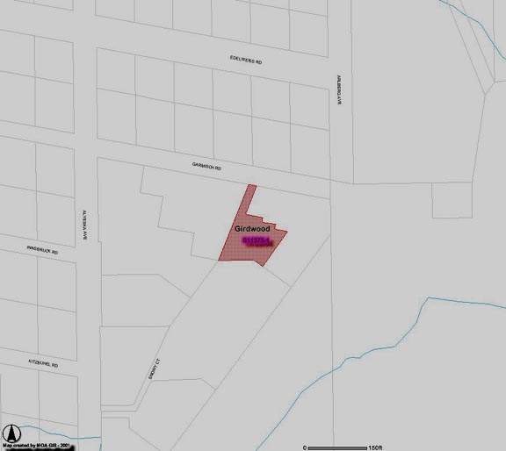
Agenda Item LUC 0505-11: Airport Master Plan Draft EIS
- Report and briefing by John McPherson received with Q&A.
- Motion: Non-objection to the draft environmental assessment 1) Diana Livingston 2) John Gallup (Yea 30; Nay 0; Abstain 11- Passed

Agenda Item LUC 0505-10: Platting Case (number is not available yet) Tim Cabana Project - 50 room hotel on Donner.
- Motion: Non-objection to the hotel and shops as presented by Tim Cabana 1) Barry Kircher 2) Chris Von Imhof (Yea 40; Nay 0; Abstain 6 - Passed
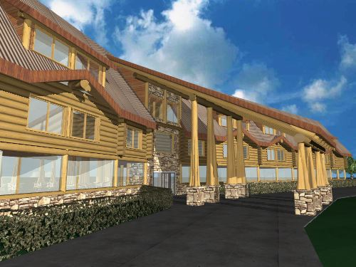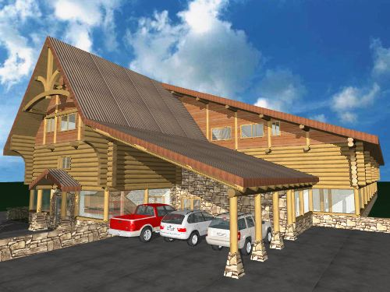
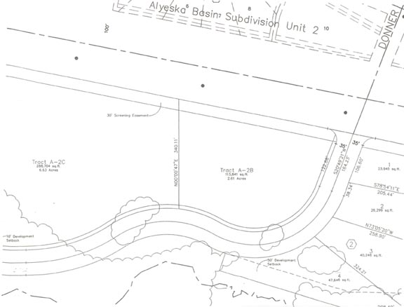

Agenda Item LUC 0505-12: Crow Creek Road Neighborhood Plan - Agnew-Beck
- LUC was briefed by Chris Beck and Robin Ward on the Crow Creek Road Neighborhood Plan with Q&A.
- Motion: LUC sends forward to GBOS a non-objection to the Crow Creek Neighborhood Plan as it is amended from the draft in March. 1) Diana Stone-Livingston 2) Dave Wilson (Yea 18; Nay 3; Abstain 4 – PASSED)

Motion to adjourn: - PASSED 10:30 PM

The above may be viewed on the Federation of Community Councils Girdwood web page at http://communitycouncils.org/girdwood/girdwood.html. Additional information will be posted there as it is received.

If you would like to receive Land Use Committee information and notification of meetings by email, please email me at Ron@Burson.org with your request.

***************************************************************

