Girdwood Land Use Committee
Notice of Agenda
November 8, 2005 Regular meeting
Revised November 2, 2005

The following items have been submitted as agenda items for consideration at this regular meeting of the Girdwood Land Use Committee. Voting members of the Land Use Committee (LUC) are any person eighteen (18) years of age or older who has been a resident and/or property owner, business owner or designated representative of a non-profit association who has resided in, owned property in, owned a business located in, or operated as a non-profit association for ninety (90) days or longer in Girdwood Valley, and in accordance with the LUC Operating Principles.

What: Regular meeting of the Girdwood Land Use Committee
Where: Glacier City Hall (next to Little Bears)
Date: November 8, 2005
Time: 7:00 pm

- Agenda Item LUC 0511-01: Officer reports, minutes approval and LUC comments and actions as necessary

- Agenda Item LUC 0511-02: Committee reports;

- Agenda Item LUC 0509-06: (Case number 2005-104 P&Z); Hearing Date: Monday Nov 07, 2005; Petitioner: MOA / Heritage Land Bank; Request Detail: Plan Amendment Crow Creek Area Master Plan. This item was postponed to October meeting by request of Art Eash. Will be carried over to November meeting at request of HLB. John Gallup briefed the LUC on the changes to the plan. The changes allow a range of from 465 to 710 housing units instead of 710 units. It moves the higher density to the upper areas as depicted in the chart. A discussion ensued regarding the dwellings per acre versus the impact on housing or lot prices and the desirability of maintaining access to trials and a forested look. Concern was expressed about the small lot sizes and the likelihood of snow machines and other items stored right up to the property lines, causing an eyesore in that part of the valley. Carried over to November meeting at request of HLB.

Area | Acres | SF Lots & Units | Attached Units | Total Housing Units/Lots | Dwelling Units/Acre
South Fan/West Highlands | 52 | 80 | 51 minimum-160 maximum | 131-240 | up to 4.6 dua
North Fan | 40 | 60 | 32 min.-100 max. | 92-160 | up to 3.5 dua
Three Ridges | 83 | 80 | 6 min.-20 max. | 86-100 | up to 1.2 dua
Lower Matrix | 28 | 40 |  | 40 | 1.3 dua
Upper Matrix | 38 | 40 | 26 min.-80 max. | 66-120 | up to 3.2 dua
Lower Forest | 40 | 50 |  | 50 | 1.2 dua
Development Areas | 281 | 350 | 115 min.-360 max. | 465-710

Rationale for the minimum number value of attached units:
- In the GAP, 23 acres in the study area are identified for multi-family residential development, with a density range of 5 to 20 units per acre. If those 23 acres were built out at 5 dua, there would be 115 units; if they were built out at 20 dua, there would be 460 units.
- The Crow Creek Plan proposes a maximum of 360 “attached” units, “attached” including single-family attached, two-family, townhouse, and multi-family housing (3+ units). Taking that value as the maximum, and knowing that the GAP calls for a minimum of 115 mf units in the area, I calculated the ratio of 115 to 360, which is 32 percent.
- Thus, the proposed minimums of attached units are 32% of the proposed maximums, and the minimum amount of attached units required to be built in the whole area matches the minimum number of multi-family designated in the GAP.

- Agenda Item LUC 0510-03: (Case number 2005-145 P&Z); Hearing date: Monday Nov 07; Petitioner: MOA; Request Detail: Plan Amendment to the Girdwood Area Plan to create consistency with land use designations proposed by the Crow Creek Area Master Plan. Carried over to November meeting at request of HLB.

- Agenda Item LUC 0511-03: Petitioner: HLB
From: Eash, Arthur S.
Sent: Wednesday, October 12, 2005 10:25 AM
To: Tracey Knutson
Subject: Snow dump
I will meet briefly with the school district about a possible snow dump site between the Creekside Apts and the school. Does GBOS want to be involved in early stages of discussion? 4 other sites have failed to pass muster; this one has tentative approval by the watershed management people, but needs ASD & Parks approval.
Snow dump area proposed near school - information will be provided when it is received.

- Agenda Item LUC 0511-04: Petitioner: The Heritage Land Bank is requesting an agency review for disposal by sealed bid sale of real property, HLB Parcel 6-019A, located in Girdwood. A public hearing by the Heritage Land Bank Advisory Commission is scheduled for Thursday, November 17th, and your input is necessary.

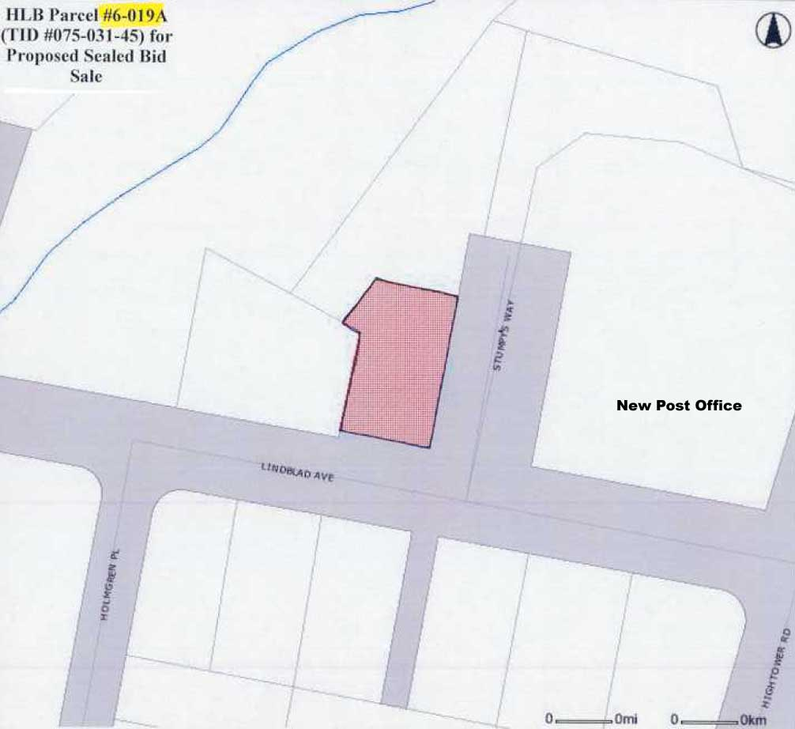

- Agenda Item LUC 0511-05: Petitioner: Mark Ryan Requesting approval of a proposed lease of HLB land for the purpose of operation of a new-to-Anchorage adventure activity called a "zip line" or flying fox" (in New Zealand). These specialized activities are comprised of certain components otherwise found in a NOLS or Outward Bound challenge course. Zip lines are participant friendly as they require little decision making by the guest and are extremely reliable. The principle idea of the activity is to take tourists with no previous knowledge of climbing techniques up into the rainforest canopy and, using a system of ropes or cables in conjunction with elevated platforms situated in the treetops, to allow the tourists to safely traverse from platform to platform. Such eco- adventure tours have proven popular in foreign and domestic markets.

** End of Agenda **
Meeting agendas and minutes may be viewed on the Federation of Community Councils Girdwood web page at http://communitycouncils.org/girdwood/girdwood.html. Updated information will be posted there as it is received.

If you would like to receive Land Use Committee information and notification of meetings by email, please email me at Ron@Burson.org with your request.

*****************************************

Girdwood Land Use Committee
V-Chm Notes (in Blue)
October 11, 2005 Regular meeting

Call to Order: 7:03 pm

Announcements:
- Conduct of Meeting:
  - Roberts Rules, informal committee of the whole to extent possible but please go through Chair to speak
  - Time limits, if necessary
- Upcoming meeting dates, events & misc. announcements
  - Community interest items
    - Rotary club looking for outbound exchange student for next year
    - Chain saws & benches at Forest Fair 10/15 from 11am to 4 pm – hot dogs and hamburgers – see attached announcement
    - Habitat for Humanity looking for 10 families to partner with – see attached packet
    - City asking for public comments to help determine the role of the Animal Care and Control Program – see attached media release
    - Weatherization Assistance Memo – PO Bulletin Board
    - PO Bulletin Board rules – max 7 days with date posted or item will be removed
  - 10/17 GBOS Meeting
  - 10/19 Federation of Community Councils – go to http:communitycouncils.org for more info
  - 11/1 Trails Committee Meeting
  - 11/8 LUC Meeting
  - Assembly Member Janice Shamberg will be unavailable for remainder of October and out of town in November and December.
  - Per John Gallup, the GBOS will have public meetings on November 11 and December 15 for public input on our budget and on the setting of our tax mil rate.
- Vote to accept for consideration any late agenda items, if any:
  - Order of Business – No changes
    - LUC Agenda item originally published as 0510-01 is renumbered to 0510-03
    - Any action on LUC agenda items 0509-06 and 0510-03 will be carried over to November 8th at the request of HLB. John Gallup will give a tentative briefing

- Agenda Item LUC 0510-01:
- Chairman’s report
  - Chapter 9 update & status
    - Chapter 9 has been passed by the Planning & Zoning Board but is not yet been added to the Assembly calendar. There will be no more public hearings and the only way for further input into the final decision on chapter 9 is to contact assembly members directly. The approved version can be viewed on the muni web site and it’s significantly than when we last saw it. They tended to cherry pick from the input form our community.
- Vice-Chairman’s report
  - None
- Secretary report
  - Approval of 9/13/05 LUC meeting minutes – see attached. The motion to approve the minutes as published by John Gallup and seconded by Ron Burson was passed with 7 yeas, 0 nays and 0 abstentions.

- Agenda Item LUC 0510-02: Committee Reports - none

- Agenda Item LUC 0509-04: (Case numbers - PLANNING & ZONING COMMISSION 2005-138 & PLATTING BOARD S11414-1); Hearing Date: Monday, Nov 07, 2005 (P&Z) & Wednesday, Oct 5, 2005 (Plat bd); Petitioner: Municipality of Anchorage; Request Detail: An ordinance of the Anchorage Municipal Assembly amending Anchorage Municipal Code Section 21.15.134, approval of plans for commercial tracts to add the PC zoning district as one of the zoning districts where commercial tracts are allowed. No representative of the petitioner was present and no action was taken. Carried over from September meeting. No action was taken on this item as the issues do not pertain to Girdwood.

- Agenda Item LUC 0509-05: (Case number S11415-1 Platting board); Hearing Date: Wednesday, Nov 02, 2005 Petitioner: Municipality of Anchorage School District; Representative: R&M Consultants, Inc., David C. Hale, Anchorage / dhale@rmconsult.com; Request Detail: To subdivide one tract of land into a different tract of land with vacation of a Right-of-Way easement / The north end of Ski View Road / Girdwood Elementary School, Tract A1, located within Section 8, T10N, R2E, S.M., Alaska. No representatively of the petitioner was present and no action was taken. Carried over from September meeting. David Hale briefed the LUC on the request for vacating of the easement at the school. The easement, which now extends into the school parking lot, will be vacated, allowing the school at some future time to restrict access to the school property. The parking lot is now being used as a turn-around so another will be constructed just before the parking lot entry. With the caveat that should the school decide to restrict access in the future to the parking lot, foot traffic access to the trails should be continued. A motion of non objection to vacating the easement, as briefed by David Hale was made by John Gallup and seconded by Ron Burson. The motion passed with 7 yeas, 0 nays and 0 abstentions.

- Agenda Item LUC 0509-06: (Case number 2005-104 P&Z); Hearing Date: Monday Nov 07, 2005; Petitioner: MOA / Heritage Land Bank; Request Detail: Plan Amendment Crow Creek Area Master Plan. This item was postponed to October meeting by request of Art Eash. Will be carried over to November meeting at request of HLB. John Gallup briefed the LUC on the changes to the plan. The changes allow a range of from 465 to 710 housing units instead of 710 units. It moves the higher density to the upper areas as depicted in the chart. A discussion ensued regarding the dwellings per acre versus the impact on housing or lot prices and the desirability of maintaining access to trials and a forested look. Concern was expressed about the small lot sizes and the likelihood of snow machines and other items stored right up to the property lines, causing an eyesore in that part of the valley. This item will be considered at our November meeting.

Area | Acres | SF Lots & Units | Attached Units | Total Housing Units/Lots | Dwelling Units/Acre
South Fan/West Highlands | 52 | 80 | 51 minimum-160 maximum | 131-240 | up to 4.6 dua
North Fan | 40 | 60 | 32 min.-100 max. | 92-160 | up to 3.5 dua
Three Ridges | 83 | 80 | 6 min.-20 max. | 86-100 | up to 1.2 dua
Lower Matrix | 28 | 40 |  | 40 | 1.3 dua
Upper Matrix | 38 | 40 | 26 min.-80 max. | 66-120 | up to 3.2 dua
Lower Forest | 40 | 50 |  | 50 | 1.2 dua
Development Areas | 281 | 350 | 115 min.-360 max. | 465-710

Rationale for the minimum number value of attached units:
- In the GAP, 23 acres in the study area are identified for multi-family residential development, with a density range of 5 to 20 units per acre. If those 23 acres were built out at 5 dua, there would be 115 units; if they were built out at 20 dua, there would be 460 units.
- The Crow Creek Plan proposes a maximum of 360 “attached” units, “attached” including single-family attached, two-family, townhouse, and multi-family housing (3+ units). Taking that value as the maximum, and knowing that the GAP calls for a minimum of 115 mf units in the area, I calculated the ratio of 115 to 360, which is 32 percent.
- Thus, the proposed minimums of attached units are 32% of the proposed maximums, and the minimum amount of attached units required to be built in the whole area matches the minimum number of multi-family designated in the GAP.

- Agenda Item LUC 0510-03: (Case number 2005-145 P&Z); Hearing date: Monday Nov 07; Petitioner: MOA; Request Detail: Plan Amendment to the Girdwood Area Plan to create consistency with land use designations proposed by the Crow Creek Area Master Plan. Will be carried over to November meeting at request of HLB.

With no further business the meeting was adjourned at 7:40 pm.

** End of Minutes **
The above minutes and agenda may be viewed on the Federation of Community Councils Girdwood web page at http://communitycouncils.org/girdwood/girdwood.html. Updated information will be posted there as it is received.

If you would like to receive Land Use Committee information and notification of meetings by email, please email me at Ron@Burson.org with your request.

*****************************************

Miscellaneous Information and Communications Received

City Takes Over Management, Operation of Penney's Garage
Moving forward on plans to renovate and manage the JC Penney parking garage as part of an effort to increase and improve parking opportunities downtown, the board of the Anchorage Community Development Authority (ACDA) has approved an agreement to enter into a long-term lease with JC Penney Co., Inc.
The plan includes investing $1.6 million to renovate the 600-space garage using funds from downtown parking revenues. Those improvements include replacing elevators, painting the interior and exterior of the garage, installing new ticket booth equipment, replacing the interior lighting, resurfacing the exit spiral, replacing the main staircase, and upgrading the plaza around the garage. The Authority will manage and operate the garage, under the terms of the lease.
Renovating and increasing the use of the Penney's garage is historic progress for downtown Anchorage, said Mayor Mark Begich. Adequate parking remains a barrier to downtown, the heart of our city. This lease allows us the opportunity to make sorely needed improvements that should entice locals and visitors alike to use this garage.
ACDA takes pride in its proactive approach to providing user-friendly, well-maintained state-of-the-art parking facilities said ACDA board chair JoAnne Zito-Brause. We have long had our eye on this garage, hoping for the chance to upgrade the structure so it can serve downtown visitors and businesses to its fullest capacity. I am excited that the opportunity has finally come, and I am confident the community will be pleased with the changes we have planned.
The ACDA voted Thursday evening to authorize the lease that runs from Jan. 1, 2006 to Dec. 30, 2020; with two five-year extensions. While final terms are being drafted, the agreement calls for the ACDA to pay JC Penney Co. Inc., $60,000 annually in rent. The ACDA will retain all revenues from parking fees. The deal also calls for no increase in parking rates for at least three years.
The Penney's garage was built in the mid 1960s. In recent years it has been seriously under-utilized, with a recent parking study showing half the spaces typically vacant at any given time. The Begich administration began talks with Penney's management more than a year ago, as prospects for a new downtown convention center became likely.
A newly-renovated Penney's garage will help serve the needs of the new convention center, planned for just a block away, along with expansion of the Anchorage Museum of History and Art.

FOR IMMEDIATE RELEASE Contact: Julie Hasquet
October 3, 2005 343-7103
2005-70
MAYOR PRESENTS FIRST-EVER BIENNIAL BUDGET
2006/2007 proposal emphasizes public safety, transportation

With a focus on holding the line on property taxes while delivering essential services and improving public safety, Mayor Mark Begich today unveiled the proposed city budgets for 2006 and 2007. He proposed the first-ever biennial budget for the Municipality, which is designed to promote stability, efficiency and greater public understanding of the budget.

In a news conference at City Hall, Mayor Begich said the 2006 proposed budget adds 20 new police employees, provides full funding for 13 School Resource Officers, and funds electronic communication improvements in support of the police and fire departments.

“A stable, predictable budget is a welcome change after the unprecedented budget gap we inherited when we first came into office,” Begich said. “Our budget proposals continue to deliver on one of the most important services any city can provide its citizens – ensuring their safety in their homes and on our streets.”

The budget also continues the Begich administration’s initiative to provide property tax relief. In 2006, the proposal gives property taxpayers the full $5 million benefit of a one-time reduction in retirement contributions approved by the State Legislature this spring. Combined with the administration’s four-part tax relief plan enacted in 2004, the percentage of property taxes required to fund city services continues to drop from 59 percent of municipal revenues in 2004 to 56 percent under the proposed 2006 budget.

“This budget reflects the three priorities Anchorage residents tell me they feel most strongly about; public safety, transportation and economic development,” Begich said. “It funds essential public services, from road maintenance to public health. It provides for modest but targeted investments in necessary public facilities, especially roads.”

The 2006 proposed budget is $362.5 million, an increase over the current year of about $29 million. The proposed 2007 budget is $376.9 million.

Begich said the biggest factors driving the budget are the increased costs of health care and retirement. The cost of health care for the Municipality of Anchorage will grow 13 percent from $25.1 million in 2005 to $28.5 million in 2006.

And statewide, the cost of public employee and teacher retirement programs are a huge liability to the State – more than $5 billion. They are an increasing burden on Anchorage’s budget, with the projection that the city’s contribution toward public employee retirement will jump considerably over the next two years, going from $13.5 million in 2005 to $17.9 million in 2006 to $29 million in 2007.

The proposed 2006 and 2007 budgets also include significant cost-savings projections. With the Cooperative Services Authority approved by the Assembly this year, Begich said the city is projecting about $1.9 million in additional savings by 2007, in the way equipment and supplies are purchased.

Begich said the capital budget will continue the emphasis on relieving traffic congestion. The administration will propose a $43 million road bond in April. Traffic congestion relief at some of the city’s busiest roads will be targeted, including 100th Avenue, 84th, Spenard, and Spruce Street, among others.

Voters also will be asked to approve a parks and recreation bond. Begich said the $3.7 million bond will support investment in vital park, trails, and recreation facilities to make the community a better place to live and raise a family.

The Budget Advisory Commission held two public meetings in May to solicit comments on the upcoming budget priorities. On October 7, the Anchorage Assembly holds its first work session on the budget. Public hearings are set for Oct. 25 and Nov. 8. Final passage of the budget is expected by Nov. 22.

From: Janice [mailto:jcshamberg@gci.net]
Sent: Monday, October 03, 2005 2:01 PM
To: Subject:

Dear Council Leaders:

Due to the Jewish High Holidays and an out-of-town trip, I will not be able to attend the following meetings scheduled for the remainder of October: Bayshore/Klatt, HALO, Oceanview, Bear Valley, Rabbit Creek, Girdwood Board of Supervisors, the Federation of Community Councils, Hillside, Hillside East and O'Malley.

I will be in town during the entire months of November and December.

My sincere apologies,

Janice Shamberg

Habitat For Humanity Anchorage is looking for 10 Families for our next project
HFHA is opening an intake process in order to find 10 qualified families who would like to own a simple decent and affordable home. We are beginning an exciting new project in the Spenard area next Spring and need families now to partner with us. Would you help spread the word for us? I have attached a brochure outlining who we are, what our process is and how families can participate. Can you let potential families know about this opportunity?
Please call or email me with any questions or if you need more information.
Margaret Forbes
Habitat for Humanity-Anchorage
Family Services Coordinator
Global Village Coordinator
Cell (907) 230-3785
Office (907) 272-0800 ext 108
FAX 272-1508
500 W. Int'l Airport Rd, Suite E
Anchorage, AK 99518

Each year, Leadership Anchorage takes on several group projects meant as a way to “give back” to the community. This year, we have 21 talented, energetic individuals representing many of the different communities and ethnicities within Anchorage and the Mat-Su Valley, and we are seeking project proposals.

If there is something you have always wanted to begin – but you lacked the labor or coordination skills in your organization – this is an opportunity for you. Please send me a Statement of Task no later than November 11, and I will see that it is considered by the group.

These are the requirements for group projects:
- They must have a definable beginning, end, and product; beginning by December 1 and ending mid-May, 2006.
- Projects must not be a fund raiser or “drone” labor. Leadership Anchorage individuals have superb coordination, communication, and organization skills – please make use of them.
- Groups are from 2-6 individuals.
- You must provide a contact person who will launch the project. She/he does not need to provide ongoing coordination (unless the project requires it), but she/he must be able to describe and define it.

On Saturday, November 19, Leadership Anchorage will meet to choose their projects. Projects will be prescreened to make sure they’re “do-able,” and if yours is selected, you may be present to introduce yours to the group (and to lobby for participants!), but that is not required. There is no guarantee your project will be selected. Time and location to be decided shortly.

Last year’s group projects included: (1) a sustainability study for Homes for Youth, an orphanage model; (2) a year-long series of monthly workshops for 4As clients; (3) creation of website digital stories for Stone Soup Group; and (4) outreach for the opening of the Alaska Museum of Natural History and the “Polar Dinosaurs” exhibit.

If you have any questions, please feel free to call me. We are here to meet existing and pressing community needs, and we know you have plenty of them. Thanks for your ideas.

Barbara Brown
Director, Leadership Anchorage
Alaska Humanities Forum
phone 272-5324
fax 272-3979
e-mail barbara.brown@akhf.org
Heritage Land Bank Advisory Commission
Regular Meeting
Thursday, November 17, 2005, 11:30
Mayor’s Conference Room (# 830)
City Hall, Anchorage, Alaska
A G E N D A
- Call to Order
- Minutes – Approval of the September 20, 2005 HLBAC Meeting Minutes
- Director’s Report
IV. Staff Reports
- Public Hearing and Proposed Action Item
a. HLBAC Resolution 2005-16: A Resolution Requesting Assembly Approval of the 3500 Tudor Road Master Plan (Robin Ward, HLB Director);
b. HLBAC Resolution 2005-17: A Resolution Requesting Assembly Approval for Disposal of the John Thomas Building Located on HLB Parcel #4-016 to the Community Foundation (R. Ward);
c. HLBAC Resolution 2005-18: A Resolution Requesting Assembly Approval for Disposal of HLB Parcel #6-019A, Located on Lindblad Avenue in the New Girdwood Town site, by Sealed Bid Sale (Art Eash, Land Management Officer);
d. HLBAC Resolution 2005-19: A Resolution Requesting Assembly Approval for the Disposal of the John Franklin Building on HLB Parcel #4-021 to Catholic Social Services, and Modification of the Brother Francis Shelter Ground Lease (R. Ward); and
e. HLBAC Resolution 2005-20: A Resolution Requesting Assembly Approval to Assist in the Purchase of Tract C-1, Eastlake Subdivision, at an Amount Not To Exceed $380,000 (R. Ward).
VII. Persons or Items Not on the Agenda
VIII. Commissioner Comments
IX. Next Meeting – Tentative: 11:30 a.m. Thursday, December 15, 2005, Conf. Rm. 155 (City Hall)
X. Adjournment
Commissioners:
Please let us know if you can/cannot attend if you have not already so notified us. Thank you!
Lynn Roderick Van Horn
Office Mgr., HLB
343-4333
Twentieth Annual International Food Festival
Sunday, November 6, 2005
Great Food: 4- 6 p.m.
Fabulous Entertainment: 4-7p.m.
Chilkoot Charlie’s
2435 Spenard Road
All you can eat!
$ 10 per person in advance
$ 12 at the door
Proceeds to benefit:
The Alaska Moose Federation Proceeds from this year's Food Fest are directed to the Alaska Moose Federation’s Junior Moose Troop youth education program. This program focuses on teaching wildlife safety to K-6 students. Whether walking to school, the bus stop or playing outside, Alaska’s many outdoor activities place kids at increased risk of surprise moose encounters. The funds generated at this event will be utilized to provide educational materials to implement the program in elementary schools around Anchorage.
Great food and entertainment
More than 40 restaurants
representing over 30 countries
For more information or to
purchase tickets call 33-Moose
Sponsored by:
Senator Lisa Murkowski and Verne Martell

