Girdwood Land Use Committee
Notice of Agenda
September 13, 2005 Regular meeting
Revised September 10, 2005

The following items have been submitted as agenda items for consideration at this regular meeting of the Girdwood Land Use Committee. Voting members of the Land Use Committee (LUC) are any person eighteen (18) years of age or older who has been a resident and/or property owner, business owner or designated representative of a non-profit association who has resided in, owned property in, owned a business located in, or operated as a non-profit association for ninety (90) days or longer in Girdwood Valley, and in accordance with the LUC Operating Principles.

What: Regular meeting of the Girdwood Land Use Committee
Where: Glacier City Hall (next to Little Bears)
Date: September 13, 2005
Time: 7:00 pm

- Agenda Item LUC 0509-01: Officer reports, minutes approval and LUC comments and actions as necessary

- Agenda Item LUC 0509-02: Committee reports;

- Agenda Item LUC 0509-03: (Case number 2005-135 / ZONING BOARD OF EXAMINERS AND APPEALS) Hearing Date: Thursday, Oct 13, 2005; Petetioner: Wayne Hendeson; Representative: Lantech - Tim Creary info@lantechi.com; Request Detail: A variance from AMC 21.40.117.G.1.b to allow a structure to encroach into the required side yard setback. Alyeska North #3 Subdivision, Block 6, Lot 7. Located on Taos Road in Girdwood.

- Agenda Item LUC 0509-04: (Case numbers - PLANNING & ZONING COMMISSION 2005-138 & PLATTING BOARD S11414-1); Hearing Date: Monday, Nov 07, 2005 (P&Z) & Wednesday, Oct 5, 2005 (Plat bd); Petitioner: Municipality of Anchorage; Request Detail: An ordinance of the Anchorage Municipal Assembly amending Anchorage Municipal Code Section 21.15.134, approval of plans for commercial tracts to add the PC zoning district as one of the zoning districts where commercial tracts are allowed.

- Agenda Item LUC 0509-05: (Case number S11415-1 Platting board); Hearing Date: Wednesday, Nov 02, 2005 Petitioner: Municipality of Anchorage School District; Representative: R&M Consultants, Inc., David C. Hale, Anchorage / dhale@rmconsult.com; Request Detail: To subdivide one tract of land into a different tract of land with vacation of a Right-of-Way easement / The north end of Ski View Road / Girdwood Elementary School, Tract A1, located within Section 8, T10N, R2E, S.M., Alaska

- Agenda Item LUC 0509-06: (Case number 2005-104 P&Z); Hearing Date: Monday Nov 07, 2005; Petitioner: MOA / Heritage Land Bank; Request Detail: Plan Amendment Crow Creek Area Master Plan

- Agenda Item LUC 0509-07: Art Eash - Heritage Land Bank request LUC review of the attached Chugach Powder Guides proposal to cut some trees along the snow cat trail, and use those trees to widen the trail. I would suggest we could stop with an "FYI" and not go on to GBOS with this. It would amount to a small amendment to a permit with CSP.



August 31, 2005

Mr. Arthur Eash
Land Management Officer
Heritage Land Bank
Municipality of Anchorage
P.O. Box 196650
Anchorage, AK 99519-6650

Dear Art,

By way of this letter we are seeking authorization to complete some minor improvements to our snowcat trail located on Heritage Land Bank land in Girdwood. The area needing improvement is located near the north end of the trail near where it leaves HLB land and enters DNR lands. We refer to this area as the Black Forest.

Since we began operations 7 years ago, this has been a problem area. There is still a considerable tree canopy over the trail in this location that hinders snow from falling onto the trail. Additionally, the terrain sidehill’s here, which is problematic for the cat. There are also a number of stumps in the way that limit our ability to farm snow from the uphill side of the trail to build a bench for the cat to operate on. The result is that on low snowfall years like last year, this area precludes us from operating for at least two to three additional weeks. We have to wait until sufficient snowfall occurs to cover this area while the rest of the trail could be easily used. Additionally it increases the chances of damage to the cat with resulting stranding of our clients.

In order to solve this problem, we are proposing removing approximately 40 trees on the uphill side of this section and placing them against the tree’s on the downhill side to create a bench and flatten the profile. We would also remove stumps on the uphill side of the bench, hand contour the soil back to it’s natural profile and re-seed any disturbed soils. This work is a modest amount of effort compared to the original trail construction, so we hope this can be accomplished with a minor amendment to the existing permit. We would like to accomplish this work in September.

Sincerely,

David Hamre

Agenda Item LUC 0509-08: Art Eash - Heritage Land Bank / Propose GAP amendments to provide for conclusions of the Crow Creek Plan. We'd also like to get on GBOS agenda for the following week. This agenda item has been postponed in accordance with the email below.
Subject: RE: Postponement of LUC item: GAP revision
Date: Wed, 7 Sep 2005 14:58:13 -0800
From: Eash, Arthur S. <EashAS@ci.anchorage.ak.us>
To: Larry Daniels <ldaniels@alyeskaresort.com>

Larry, HLB needs to postpone item #0509-08 (GAP amendments) until October. We haven't finished writing our script yet! Please pardon any inconvenience, and thanks.

** End of Notice **
The above agenda may be viewed on the Federation of Community Councils Girdwood web page at http://communitycouncils.org/girdwood/girdwood.html. Additional information will be posted there as it is received.

If you would like to receive Land Use Committee information and notification of meetings by email, please email me at Ron@Burson.org with your request.

*****************************************
Miscellaneous Information and Communications Received

CITY HOSTING TITLE 21 WORKSHOPS FOR COMMUNITY COUNCILS
In an effort to help educate Anchorage residents about the importance of the rewrite of the Title 21 land use code, the Municipality of Anchorage this Wednesday begins a series of four regional workshops involving the city's community councils.
Mayor Mark Begich, Planning Director Tom Nelson and other staff will give an overview of Title 21, and then give those at the workshops a chance to ask questions about the draft document that was released in June.
The code rewrite, known as Project 21, is part of the citys multi-year process of updating land use regulations. It will affect how development will take place in Anchorage for decades to come.
The workshops with the community councils are part of an 11-week public review period designed to get comments from all parts of the community before the next draft is available for public review. The Planning and Zoning Commission and the Anchorage Assembly will hold joint hearings in the Spring of 2006.
The following is a list of the community councils and the dates of their workshops:
Sept. 7 Bear Valley Elementary School 7-9 pm
Bear Valley
Huffman/OMalley Hillside East
Mid-Hillside Glen Alps
Rabbit Creek Turnagain Arm
Abbott Loop Old Seward/Oceanview
Girdwood Portage
*********

From: Community Councils [councils@ak.net]
Sent: Monday, June 27, 2005 8:08 AM
Subject: FW: Anchorage Woodlot Hours

The wood disposal lot hours have been extended, at least for the south Anchorage lot at C and Minnesota. This is an important development because the hours have been very short this season.

The Anchorage Soil & Water Conservation District has extended the hours of operation of the Anchorage Woodlot effective immediately. The new hours are as follows:

Monday through Thursday 9am - 8pm
Friday through Sunday 10am - 6pm

For more information, go to http://www.muni.org/fire1/Woodlots.cfm

Thank you,
Ryan Stencel
Operations Manager
Anchorage Soil & Water Conservation District

Additional information:
Municipal Wood Lots are for the disposal of wood and brush by private homeowners. No stumps, garbage, metal, or construction materials will be allowed. There is no charge for disposal at either the Anchorage or Eagle River Wood Lots.

For garden wastes:
Anchorage Regional Composting Facility
Contact: Pete Kineen 243-8577

Accept wood of any kind, leaves, brush, grass, stable waste.
7895 West End Rd, 3.7 mi. west of Northern Lights Blvd. and Postmark Rd.

Nominal fee charged.

********************* Minutes from August 9, 2005 Meeting********************

Land Use Committee
August 9, 2005
Minutes
Call to Order: 7:02 pm by Chm Larry Daniels

Announcements:
- Conduct of Meeting:
  - Roberts Rules, informal committee of the whole to extent possible but please go through Chair to speak
  - Time limits, if necessary
- Upcoming meeting dates, events & misc. announcements
  - Community interest items on last pages of agenda
    - Hazardous Forest Fuel Treatment/ Habitat Enhancement Demo
    - Weatherization Assistance Memo – PO Bulletin Board
    - MOA Casting Call
    - PO Bulletin Board – about three weeks
  - 8/15 GBOS
  - 8/17 Federation of Community Councils – go to web site for more info
    - http:communitycouncils.org
  - 8/22 Public Hearing on Chapter 9 – Location to be determined. Be prepared to express your concerns specifically, they want details, not generalizations.
  - 9/6 Trails Committee
  - 9/13 LUC
- Agenda Item LUC 050804 moved to first item to be considered due to Joe Wolner time constraints. No objections.

Agenda Item LUC 0508-01: Officer Reports & LUC comments and actions as necessary.
- Chairman’s report
  - Chapter 9 update & status
    - Joint Assembly meeting Aug 4th at hotel – Larry gave a brief synopsis of the workshop/meeting.
- Vice-Chairman’s report
  - None
- Secretary report
  - Approval of 7/12/05 LUC meeting minutes –
    - 1) Ellen Twiname 2) John Gallup; Approved as published Yea 10, Nay 0, Abstain 0

- Agenda Item LUC 0508-02: Committee reports; None

- Agenda Item LUC 0506-03: (Case number 2005-082) Hearing Date: Monday, Jul 11, 2005; Petitioner: Tim Cabana; Request Detail: A conditional use for parking calculations, landscaping and sign regulations for a hotel. Alpine View Estates Phase 1, Tract A-2C. Located on the south side of the Alyeska Highway, west of Timberline Drive in Girdwood; Legal Desc.: R-11 Turnagain Arm district; Site Address: NHN KAMI WAY. For further information, refer to Agenda Item LUC 0505-10 (Case Number not available) Tim Cabana Project - 50 room hotel on Donner.
Although a case number was not available at the time the LUC took with the following action at the May 10, 2005 meeting:
Motion: Non-objection to the hotel and shops as presented by Tim Cabana.
1) Barry Kircher 2) Chris Von Imhof Passed (Yea 40; Nay 0; Abstain 6)
Although no representative was in attendance to present this case, action taken by the LUC at the June 14th meeting was:
Motion: Pass on to GBOS for their action with no recommendation from LUC.
1) John Gallup 2) Kevin McDermott Passed: (Yea 8; Nay 0, Abstain 3)

This matter may have already been completed but is being included in the agenda in case it needs to be considered again by the LUC. The petitioner need not be present unless further action is desired. Action will be taken as deemed appropriate by the LUC.
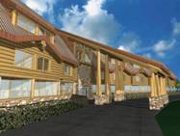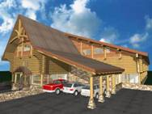
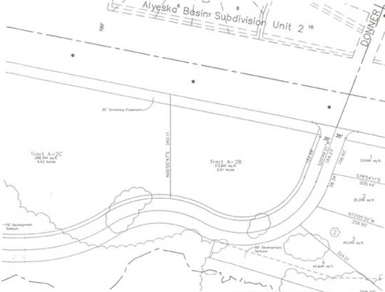

No action taken on this item due to no representative or information available.

- Agenda Item LUC 0507-05: (Case number 2005-108) Hearing Date: Monday, Sep 12, 2005; Petitioner: Per Bjorn-Roli, PO Box 110903, Anchorage, AK 99511, E-Mail: perbjornroli@aol.com; Request: A conditional use to allow a 12-plex multiple family residential structure in the R-11 zoning district. Alyeska Subdivision, Block 6A, Lot 11A (Now platted as Lot 11B). Located on Garmisch Drive; R-11 Turnagain Arm district.
Reference previous agenda item LUC 0505-09 Platting Case S11375-1 Per Bjorn-Roli To subdivide two lots into two different lots. East of Alyeska Avenue and south of Garmisch Road. Alyeska Subdivision, Block 6A, Lot H1A & I1A, located within the NW1/4 of Section 16, T10N, R2E, S.M., Alaska. Fred Walatka & Associates (Hearing date 5/30/05)
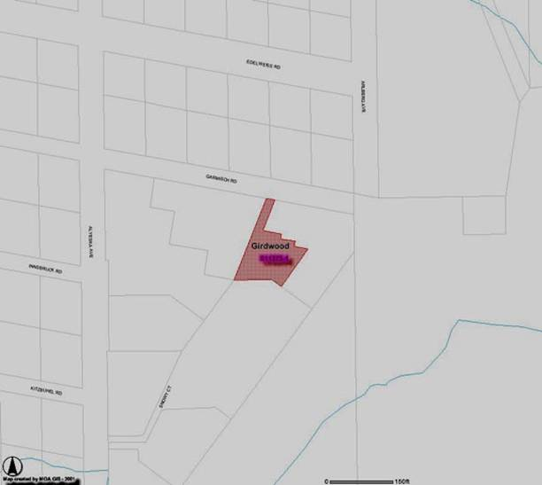

Yvonne Safar, General Contractor for the project, briefed those present on the project followed by a question and answer period.
- There will be four buildings, each with three units
- Varied in size from 1200 sq. ft. to 2100 sq. ft.
- Building coverage approximately 25 % of lot (40% allowed)
- Meets height and set back criteria
- Will be landscaped for summer and winter
- Road and driveways will be heated so no snow removal needed – no water runoff
- Existing condos on both sides
- George McCoy will be exclusive agent
- Projected schedule
  - Site work in 2005
  - 2 buildings completed in 2006 – maybe more depending on sales
- Will be first class project
After several attendees complimented Per and Yvonne on the project, the LUC action was to pass a resolution of non-objection to the project as briefed by Safar and Per Bjorn Roli. 1) John Gallup 2) Diana Livingston; Passed Yea 17, Nay 0, Abstain 0

- Agenda Item LUC 0508-03: Diana Livingston
A RESOLUTION OF THE GIRDWOOD BOARD OF SUPERVISORS Land Use Committee SUPPORTING ESTABLISHMENT OF A GIRDWOOD MUSEUM IN THE HISTORIC ROUNDHOUSE BUILDING.
WHEREAS, the community that became Girdwood traces its beginnings to the discovery of gold in the late 19th century and took its name from an early miner, and
WHEREAS, Girdwood is the northwest boundary of the nation’s second largest national forest established by President Theodore Roosevelt in 1907 to protect the region’s natural resources from further exploitation by the Alaska Syndicate, and
WHEREAS, documents were first filed fifty years ago in 1955 to acquire land in Girdwood for a ski resort, and
WHEREAS, the Alyeska Roundhouse was constructed in 1960 as the terminus to the first chairlift, and
WHEREAS, the Alyeska Roundhouse was placed on the National Register of Historic Places in 2003 and efforts began to raise funds to renovate the Roundhouse and establish a museum to commemorate and preserve Girdwood’s unique history, and
WHEREAS, funding has been substantially established to insure the completion of this project, along with agreements for perpetuating the maintenance, operation and staffing of the Roundhouse Museum, with no liability to the Girdwood Community, now, therefore,
BE IT RESOLVED that the Girdwood Board of Supervisors Land Use Committee supports the project to renovate the Alyeska Roundhouse and develop a museum dedicated to preserving Girdwood’s history.
PASSED AND APPROVED BY THE GIRDWOOD BOARD OF SUPERVISORS Land Use Committee ON August 9, 2005. 1) Per Bjorn Roli 2) John Gallup; (Yea: 17, Nay: 0, Abstain: )

- Agenda Item LUC 0508-04: Joseph Wolner, Girdwood, AK - Request for a resolution of support for the Girdwood Playground Committee plans. The Girdwood Playground Committee was formed to undertake the renovation of the Community Park known as Little Bears Playground located at the corner of Alyeska Highway and Hightower Road, Girdwood, Alaska. Our purpose is to create a safe and fun playground that reflects the spirit, artistry, and imagination of our community. The goal is to guarantee a playground that meets safety standards with accessibility for all children.
Concerned parents along with Anchorage Parks and Recreation formed this Committee to define the plans for installing a safe, environmentally sound, accessible playground. Also to begin a fund-raising drive to reach our goal of renovating the playground.
The Committee's campaign goal is to reach $100,000 and to complete the playground project in the summer of 2006.
Forest Fair is our current Fiscal Sponsor. This means that all donations will go through the Forest Fair into an account for the Playground Renovation. We chose a Fiscal Sponsor rather than applying for non-profit status on our own due to the short period that this project will take. Also being that the Forest Fair Park is connected to the playground, it was a perfect fit. The Forest Fair set us up to run the Root Beer Garden this year and we Grossed $2400 (not a bad start).
By vote in February 2005 our committee decided to go with a Leathers and Associates design. http://www.leathersassociates.com/
This type of design will allow for a unique structure that will reflect the Girdwood Community. There are 3 playgrounds in Alaska designed by Leathers (Wasilla, Palmer, and Haines. http://hainesak.com/playground/).
Those who have seen their playgrounds agree that it would blend with Girdwood's character. The design is based on community input before and during the Design Day. The Design Day is really a kick-off event that gets the community jazzed about the project and incorporates the ideas and input of the children, artisans, and the community as a whole.
According to Robin Ward of HLB: "I did some checking and found out that it is city land managed by Parks and Rec. Chad should be able to answer your questions, but if you need any help, please don't hesitate to call me." I'll be presenting and have pictures available of Leathers projects. If something comes up I'll be sure to have a representative in my place.
We are very excited about the project!
Please let me know if you need any additional information.
- Joe Wolner briefed those present on the needs and projected schedule. After a question and answer period, the LUC passed the following resolution.
- Be It Resolved that the Land Use Committee supports the project to renovate the Little Bears Playground.
1) John Gallup 2) Diana Livingston; (Yea: 13, Nay: 0, Abstain: 0)

The meeting was adjourned at 7:42 pm.

** End of minutes **
The above may be viewed on the Federation of Community Councils Girdwood web page at http://communitycouncils.org/girdwood/girdwood.html. Additional information will be posted there as it is received.

If you would like to receive Land Use Committee information and notification of meetings by email, please email me at Ron@Burson.org with your request.

