Land Use Committee
August 9, 2005
Order of Business
Call to Order:

Announcements:
- Conduct of Meeting:
  - Roberts Rules, informal committee of the whole to extent possible but please go through Chair to speak
  - Time limits, if necessary
- Upcoming meeting dates, events & misc. announcements
  - Community interest items on last pages of agenda
    - Hazardous Forest Fuel Treatment/ Habitat Enhancement Demo
    - Weatherization Assistance Memo – PO Bulletin Board
    - MOA Casting Call
    - PO Bulletin Board – about three weeks
  - 8/15 GBOS
  - 8/17 Federation of Community Councils – go to web site for more info
    - http:communitycouncils.org
  - 8/22 Public Hearing on Chapter 9
  - 9/6 Trails Committee
  - 9/13 LUC
- Vote to accept for consideration any late agenda items, if any:
  - Announce Order of Business - Reason for any changes if different than published:

Agenda Item LUC 0508-01: Officer Reports & LUC comments and actions as necessary.
- Chairman’s report
  - Chapter 9 update & status
    - Joint Assembly meeting Aug 4th at hotel
- Vice-Chairman’s report
  - None
- Secretary report
  - Approval of 7/12/05 LUC meeting minutes – see attached

Agenda Item LUC 0506-02: Committee Reports
- Any other committee reports?

Go to Highlighted agenda item on next page
Girdwood Land Use Committee
Notice of Agenda
August 9, 2005 Regular meeting

The following items have been submitted as agenda items for consideration at this regular meeting of the Girdwood Land Use Committee. Voting members of the Land Use Committee (LUC) are any person eighteen (18) years of age or older who has been a resident and/or property owner, business owner or designated representative of a non-profit association who has resided in, owned property in, owned a business located in, or operated as a non-profit association for ninety (90) days or longer in Girdwood Valley, and in accordance with the LUC Operating Principles.

What: Regular meeting of the Girdwood Land Use Committee
Where: Glacier City Hall (next to Little Bears)
Date: August 9, 2005
Time: 7:00 pm

- Agenda Item LUC 0508-01: Officer reports, minutes approval and LUC comments and actions as necessary

- Agenda Item LUC 0508-02: Committee reports;

- Agenda Item LUC 0506-03: (Case number 2005-082) Hearing Date: Monday, Jul 11, 2005; Petitioner: Tim Cabana; Request Detail: A conditional use for parking calculations, landscaping and sign regulations for a hotel. Alpine View Estates Phase 1, Tract A-2C. Located on the south side of the Alyeska Highway, west of Timberline Drive in Girdwood; Legal Desc.: R-11 Turnagain Arm district; Site Address: NHN KAMI WAY. For further information, refer to Agenda Item LUC 0505-10 (Case Number not available) Tim Cabana Project - 50 room hotel on Donner.
Although a case number was not available at the time the LUC took with the following action at the May 10, 2005 meeting:
Motion: Non-objection to the hotel and shops as presented by Tim Cabana.
1) Barry Kircher 2) Chris Von Imhof Passed (Yea 40; Nay 0; Abstain 6)
Although no representative was in attendance to present this case, action taken by the LUC at the June 14th meeting was:
Motion: Pass on to GBOS for their action with no recommendation from LUC.
1) John Gallup 2) Kevin McDermott Passed: (Yea 8; Nay 0, Abstain 3)

This matter may have already been completed but is being included in the agenda in case it needs to be considered again by the LUC. The petitioner need not be present unless further action is desired. Action will be taken as deemed appropriate by the LUC.
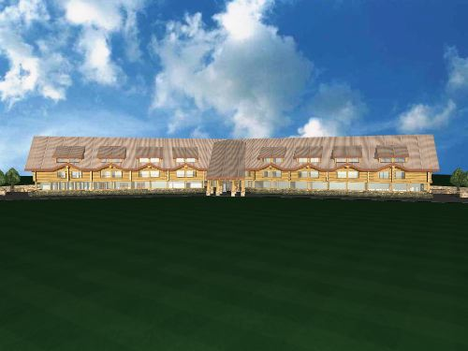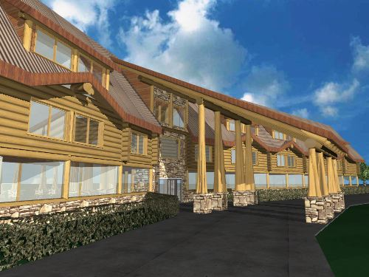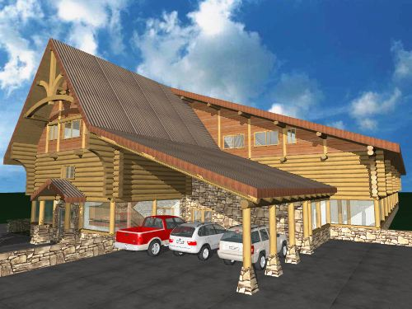
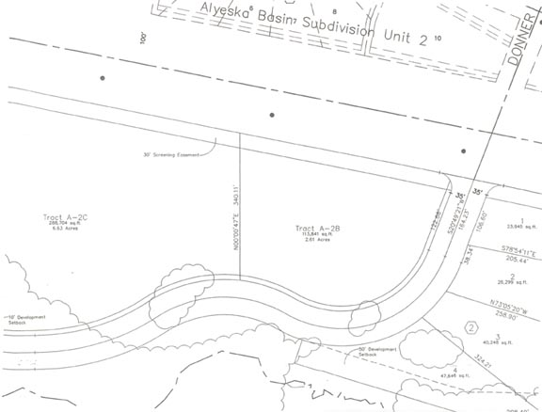

- Agenda Item LUC 0507-05: (Case number 2005-108) Hearing Date: Monday, Sep 12, 2005; Petitioner: Per Bjorn-Roli, PO Box 110903, Anchorage, AK 99511, E-Mail: perbjornroli@aol.com; Request: A conditional use to allow a 12 plex multiple family residential structure in the R-11 zoning district. Alyeska Subdivision, Block 6A, Lot 11A (Now platted as Lot 11B). Located on Garmisch Drive; R-11 Turnagain Arm district.
Reference previous agenda item LUC 0505-09 Platting Case S11375-1 Per Bjorn-Roli To subdivide two lots into two different lots. East of Alyeska Avenue and south of Garmisch Road. Alyeska Subdivision, Block 6A, Lot H1A & I1A, located within the NW1/4 of Section 16, T10N, R2E, S.M., Alaska. Fred Walatka & Associates (Hearing date 5/30/05)
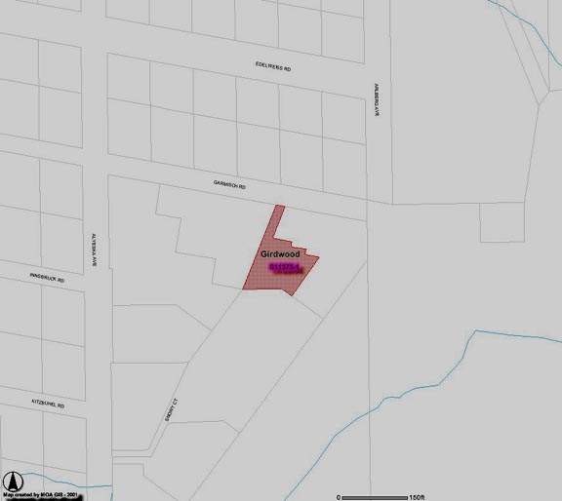

- Agenda Item LUC 0508-03: Diana Livingston
A RESOLUTION OF THE GIRDWOOD BOARD OF SUPERVISORS Land Use Committee SUPPORTING ESTABLISHMENT OF A GIRDWOOD MUSEUM IN THE HISTORIC ROUNDHOUSE BUILDING.
WHEREAS, the community that became Girdwood traces its beginnings to the discovery of gold in the late 19th century and took its name from an early miner, and
WHEREAS, Girdwood is the northwest boundary of the nation’s second largest national forest established by President Theodore Roosevelt in 1907 to protect the region’s natural resources from further exploitation by the Alaska Syndicate, and
WHEREAS, documents were first filed fifty years ago in 1955 to acquire land in Girdwood for a ski resort, and
WHEREAS, the Alyeska Roundhouse was constructed in 1960 as the terminus to the first chairlift, and
WHEREAS, the Alyeska Roundhouse was placed on the National Register of Historic Places in 2003 and efforts began to raise funds to renovate the Roundhouse and establish a museum to commemorate and preserve Girdwood’s unique history, and
WHEREAS, funding has been substantially established to insure the completion of this project, along with agreements for perpetuating the maintenance, operation and staffing of the Roundhouse Museum, with no liability to the Girdwood Community, now, therefore,
BE IT RESOLVED that the Girdwood Board of Supervisors Land Use Committee supports the project to renovate the Alyeska Roundhouse and develop a museum dedicated to preserving Girdwood’s history.
PASSED AND APPROVED BY THE GIRDWOOD BOARD OF SUPERVISORS Land Use Committee ON August 9, 2005. 1) 2)
(Yea: Nay: Abstain: )

- Agenda Item LUC 0508-04: Joseph Wolner, Girdwood, AK - Request for a resolution of support for the Girdwood Playground Committee plans. The Girdwood Playground Committee was formed to undertake the renovation of the Community Park known as Little Bears Playground located at the corner of Alyeska Highway and Hightower Road, Girdwood, Alaska. Our purpose is to create a safe and fun playground that reflects the spirit, artistry, and imagination of our community. The goal is to guarantee a playground that meets safety standards with accessibility for all children.
Concerned parents along with Anchorage Parks and Recreation formed this Committee to define the plans for installing a safe, environmentally sound, accessible playground. Also to begin a fund-raising drive to reach our goal of renovating the playground.
The Committee's campaign goal is to reach $100,000 and to complete the playground project in the summer of 2006.
Forest Fair is our current Fiscal Sponsor. This means that all donations will go through the Forest Fair into an account for the Playground Renovation. We chose a Fiscal Sponsor rather than applying for non-profit status on our own due to the short period that this project will take. Also being that the Forest Fair Park is connected to the playground, it was a perfect fit. The Forest Fair set us up to run the Root Beer Garden this year and we Grossed $2400 (not a bad start).
By vote in February 2005 our committee decided to go with a Leathers and Associates design. http://www.leathersassociates.com/
This type of design will allow for a unique structure that will reflect the Girdwood Community. There are 3 playgrounds in Alaska designed by Leathers (Wasilla, Palmer, and Haines. http://hainesak.com/playground/).
Those who have seen their playgrounds agree that it would blend with Girdwood's character. The design is based on community input before and during the Design Day. The Design Day is really a kick-off event that gets the community jazzed about the project and incorporates the ideas and input of the children, artisans, and the community as a whole.
According to Robin Ward of HLB: "I did some checking and found out that it is city land managed by Parks and Rec. Chad should be able to answer your questions, but if you need any help, please don't hesitate to call me." I'll be presenting and have pictures available of Leathers projects. If something comes up I'll be sure to have a representative in my place.
We are very excited about the project!
Please let me know if you need any additional information.
Motion: The LUC supports the plans of the Girdwood Playground Committee.
1) 2)
(Yea: Nay: Abstain: )

** End of Notice **
The above agenda may be viewed on the Federation of Community Councils Girdwood web page at http://communitycouncils.org/girdwood/girdwood.html. Additional information will be posted there as it is received.

If you would like to receive Land Use Committee information and notification of meetings by email, please email me at Ron@Burson.org with your request.

*****************************************
Miscellaneous Information and Communications Received

From: Community Councils [councils@ak.net]
Sent: Monday, June 27, 2005 8:08 AM
Subject: FW: Anchorage Woodlot Hours

The wood disposal lot hours have been extended, at least for the south Anchorage lot at C and Minnesota. This is an important development because the hours have been very short this season.

The Anchorage Soil & Water Conservation District has extended the hours of operation of the Anchorage Woodlot effective immediately. The new hours are as follows:

Monday through Thursday 9am - 8pm
Friday through Sunday 10am - 6pm

For more information, go to http://www.muni.org/fire1/Woodlots.cfm

Thank you,
Ryan Stencel
Operations Manager
Anchorage Soil & Water Conservation District

Additional information:
Municipal Wood Lots are for the disposal of wood and brush by private homeowners. No stumps, garbage, metal, or construction materials will be allowed. There is no charge for disposal at either the Anchorage or Eagle River Wood Lots.

For garden wastes:
Anchorage Regional Composting Facility
Contact: Pete Kineen 243-8577

Accept wood of any kind, leaves, brush, grass, stable waste.
7895 West End Rd, 3.7 mi. west of Northern Lights Blvd. and Postmark Rd.

Nominal fee charged.

*****************

August 2, 2005
Subject: Hazardous Forest Fuel Treatment/ Habitat Enhancement Demo.
Attn: Demonstration Invitees:
The Alaska Moose Federation and Alaska Village Initiatives would like to invite
you and all persons interested to a demonstration of new forest treatment
technology and techniques. The new machines being used are designed to be
easy on the land with low ground pressure, eliminating the risk of a catastrophic
wildfire while returning forests to healthy, natural states.
The key reason for our involvement with these forest practices, while rebuilding
the health of our forests, is that they will create better wintering habitat for
Alaska’s moose. Rising vehicle and railroad collisions with moose is as
unacceptable as increasing hazardous moose occurrences on school grounds
and in neighborhoods. As community development continues within moose
habitat, areas away from the communities must be treated to encourage moose
off of our roads and away from schools and neighborhoods. Current conditions
of severe catastrophic fire danger threatens many Alaskans throughout the state.
Let us take control of our safety within this wildland urban interface and quit living
with fear from hazardous wildfire and increasing moose collisions on our
highways.
Please consider witnessing this demonstration to turn our insect and disease
infected forest stands next to our communities into healthy pioneer forests we all
can use and enjo y for future generations. Bring your raingear, walking shoes
and bug dope with a n open mind to see the latest developments in forest
management in other states and countries which face similar hazards of
catastrophic wildfire have embraced this protocol to help the forests we all live in
and cherish.
Please RSVP via e-mail golson@growmoremoose.org or 336-6673 for this event.
Sincerely,
Gary Olson, Chairman Charles Parker, Director
Alaska Moose Federation Alaska Village Initiatives
Phone: (907) 336-6673 Phone: (907) 274-5400 ext. 846
golson@growmoremoose.org cparker@akvillage.com
Event: Hazardous Fuel Treatment/ Habitat Enhancement Demonstration
Date: August 10, 2005
Time: 9:00 a.m. - 1:00 p.m.
Where: Meeting will begin at the Alaska Moose Center (Tanglewood Lakes
Lodge) at 11701 Brayton Drive. Our headquarters is located on the
frontage road next to the indoor golf driving dome at Huffman &
New Seward Highway.
Demonstration location will be approximately 4 miles above Potters
Marsh on a private land owner's property.
9:30 a.m. Bus leaves headquarters to homestead.
10:00 a.m. Demonstration begins.
10:20 a.m. Review and explanation of treated area.
10:50 a.m. Bus returns to headquarters.
11:20 a.m. Arrive at headquarters, refreshments upstairs.
11:30 a.m. Supertrak’s presentation.
11:40 a.m. NPI, LLC presentation.
11:55 a.m. Alaska Moose Federation/ Alaska Village Initiatives
presentation, questions and answers.
12:00 p.m. Lunch and open discussion.
Equipment being demonstrated: http://www.supertrak.com/tl150.htm
http://www.supertrak.com/sk120tr.htm

***********************
WOULD YOU LIKE TO BE AN ACTOR?
SPEND AUGUST 18TH AT KINCAID PARK?
HERE’S YOUR CHANCE TO PROVIDE A SERVICE,
SPEND A DAY OUTDOORS AND HAVE FUN!
We’re looking for 150 volunteers willing to be “victims for a day”
Thursday, August 18 at Kincaid Park from 9:30am until 3:30pm!
Volunteers will play victims of a major disaster in Anchorage.
Specific roles and injuries will be assigned at the park.
“Injuries” (created from makeup and latex) will range from cuts and
bruises to broken limbs and major injuries – even some fatalities.
(All simulated, of course!)
Some “victims” will be treated on site, others will be transported
to local hospitals. (All volunteers will be returned to Kincaid
before the end of the exercise!)
We need people willing to give 5 to 6 hours of their time!
We need volunteers of all ages – adults and children!
A great opportunity for service clubs, scout troops or anyone interested.
Please join us! With your help, our community will be better prepared
to face real emergencies in the future!
If you would like to be part of this event, please contact the
MOA Office of Emergency Management
at 343-1404 or moranme@muni.org.

********************* Minutes from July 12, 2005 Meeting********************

Girdwood Land Use Committee
Meeting Notes in blue
July 12, 2005 Regular meeting
Meeting called to order: 7:00 pm, thirteen people were present.
• Agenda Item LUC 0507-01: Officer reports, minutes approval and LUC comments and actions as necessary
Chairman - nothing to report.
Vice Chair - absent.
Secretary - Motion to approve the minutes from the June meeting.
1. Twiname 2. Zaccaro PASSED (6-0-0)
We all agreed to move Alison Rein's agenda item to the front so she wouldn't have to sit through the whole meeting with her small child.
Agenda Item LUC 0507-06: Alison Rein, arein@fs.fed.us
The Forest Service has applied for an easement from HLB for a trailhead at approx. mile 2.9 (about 1/4 mile downhill from the road into the Mine), on the downhill side of the road. Art Eash told me to present this to Land Use for their approval, then it should get sent on to GBOS. Trailhead would accommodate up to twenty (20) vehicles, have an outhouse (vault toilet) and interpretive / informational signs.
We (USFS) initially planned to build this trailhead on the uphill side of the road- which is still Forest Service Land, but I was not able to fit a road into this side under 12% slope.
From: Alison M Rein [arein@fs.fed.us]
Sent: Friday, June 24, 2005 9:37 AM
To: ron@burson.org; afkes@uaa.alaska.edu; frankcm@muni.org
Subject: agenda item LUC & gird trails:
I'd like to have the following on the agenda's for the July meetings:
Approval/support of grant application for reconstruction of Alyeska Highway Bike Trail, between the Forest Service Driveway and Crow Creek Road.
Background: Girdwood Trails is one of the named trails in the Fiscal Year 2005 Omnibus Appropriations Act sponsored by Senator Stevens. The Act included a section called "Alaska Trails Initiative" with a 4 million dollar allotment. Sixteen named trails or facilities were listed, including "Girdwood Trails" The Girdwood Trails committee developed a prioritized list in December 2003 when another funding opportunity was imminent, and the Alyeska Bike Path improvement was on the top of the list at this time. The pathway has deteriorated over time, due to culvert heaving, cutting and patching to install utilities, and frost heave. Presently many bicyclists are using the roadway shoulder because of the uneven, bumpy condition of the pathway. Grant applications are due in by July 22.
We may further narrow down or prioritize the application in order to be more competitive for an award, and will look at the bike path for the most needy section. If there's any opportunity to get funds from other sources so that the entire pathway could be restored, the unit cost will be lower than doing it in small sections.
I will be present at both meetings to answer any questions regarding this proposal.
I understand recommendations from the 2 committees are forwarded on to GBOS for their consideration, so there would not be time for a resolution from GBOS to be included in our grant application. I hope we can discuss how to have GBOS support included in our grant application.
Motion: That we go ahead and approve this parking easement with the opportunity to see the design for review when it's ready.
1. Powers 2. Zaccaro PASSED (9-0-2)
• Agenda Item LUC 0502-03: (Case Number: 2005-096); Planning & Zoning Commission and Assembly Hearing Date: Wednesday, Jul 20, 2005; Petitioner: Municipality of Anchorage; Detail: AN ORDINANCE AMENDING ANCHORAGE MUNICIPAL CODE TO ADD A NEW CHAPTER 21.09, GIRDWOOD LAND USE REGULATIONS, AMENDING THE ZONING MAP ACCORDINGLY, AND AMENDING CHAPTER 21.40 TO ADD GIRDWOOD USE DISTRICTS. (old business from February, March, April, May and June meetings) The resolution passed by the LUC at the May 10, 2005 meeting is as follows: In keeping with the deliberative process move forward with the May 18 & 21 Public meetings and then decide at the July LUC meeting how best to move forward and that we be allocated a minimum of 30 days to review the next draft.
Text of the letter sent by the GBOS to the Land Use Committer on May 17, 2005 is as follows:
On Monday, May 16, 2005, the Girdwood Board of Supervisors ("GBOS") voted unanimously on a resolution to forward the recommendations from the May 18, 2005 and May 21, 2005 work sessions and the May 25,2005 GBOSILUC joint meeting to the Municipality's Planning Department, so that the planning folks can complete the Chapter 9, Title 21 public review draft and remain on their timetable to complete Chapter 9 in 2005.
This resolution is at odds with the portion of the Land Use Committee ("LUC") resolution 0502-03, which sought to defer action on Chapter 9, Title 21 until the July LUC meeting.
Please be advised that the GBOS took this action in the hopes of keeping Chapter 9 on schedule because the GBOS felt, after much discussion, that it is critical to keeping other large projects in Girdwood on schedule. The GBOS felt that the delay of one (1) year in the Title 21 project would be detrimental to these other projects. The GBOS also felt that, in light of all the recent interest in Chapter 9, that it was in the community's best interest to "keep the ball rolling" and to urge the community members to work diligently in the next few weeks to arrive at a draft that would be acceptable to all concerned.
After all the recent discussion, the GBOS feels that the current draft of Chapter 9, Title 21 which is the product of almost four (4) years of effort on the part of the subcommittee, is approaching that "golden mean", and that with a little more effort the community can have a finished draft.
Resolutions passed by the LUC at the June 14, 2005 meeting are as follows:
The Girdwood LUC wishes the Assembly to consider some type of grandfather rights for property owners who have improved properties which were constructed or whose plans were approved for construction prior to the passage of Chapter 9 of Title 21. In addition it is requested that Planning & Zoning and the Assembly have an expedited and less costly variance process for Girdwood property owners impacted by the changes brought on by passage of these regulations. 1)John Gallup 2)Kevin McDermott - PASSED (11-0-0)
Motion: Put GBOS on notice that the LUC may be forwarding additional comments / recommendations on the proposed Chapter 9 of Title 21 for the July 18, 2005 meeting and for the Planning and Zoning hearing on July 20, 2005.
1) Larry Daniels 2) John Gallup Passed: Yea 11; Nay 0; Abstain 0
In view of the above information, GBOS Rules and Procedures, LUC Operating Principles and previous action by the LUC and the GBOS, the LUC will consider and take action as deemed appropriate.
Steve Halverson said he will email his comments regarding fences. (no email received yet) He wants to maintain Girdwood's current unfenced look. After some discussion, it was agreed to reduce the new standard from 30% to 20%.
Motion: to change the June Draft, Page 80, I. Fences and Walls, Paragraph 1 to read "Fences up to eight (8) feet in height are permitted in side and rear setback areas, where needed for child safety, privacy, security, or animal control. However, in no case shall fences extend into more than one setback and for more than 20% of the total linear perimeter of the lot. Fences are prohibited in the front setback." 1.Halverson/2.Powers PASSED (7-2-2)
Marco Zaccaro thought that the parking lot landscaping paragraph in the June Draft would make parking lots 25% bigger. After some discussion, a change was agreed on.
Motion: to change the June Draft, Page 83, 6. Parking Lot Landscaping to read "Public and private parking lots shall have a twenty foot landscaped break in any line of parking spaces over twenty cars long and a minimum fifteen foot landscaped strip between every other double-loaded bay of cars. For parking lots over 140 spaces or less than 60, a landscaped strip twenty feet in width shall be required between every other bay."
1. Zaccaro 2. Powers PASSED (6-0-5)
Then Larry Daniels handed out a list of changes he wanted on behalf of Alyeska Resort. After some discussion, Larry's list was adopted with a few amendments. Here is the list as amended...
AMENDMENTS TO SECTION 21.09.030
ADMINISTRATION AND REVIEW PROCEDURES
(Page 7)
E. Area Master Plan

3. Procedures

e. Submittal Requirements
Amendment is delete “and/or the Director”

(Page 8)
iv.
Amendment is add “mapping of 1” = 200’ or as required by Director”

v. Amendment is change text to “A general description of the existing vegetation, [habitat], and soils in the petition area [if required by Director];

vi. Amendment is to add “existing trails”

viii. Amendment is to add “Traffic Study, if required by Director”

Add the following sections:

xiv. An analysis of offsite impacts for utilities and public services including impacts to public schools, fire and police services if required by Director;

xv. Detailed discussion of conformance with GAP, Transportation Plan, Trail Plan and other current Girdwood Area Planning documents, if required by Director;

xvi. Compliance with 21.09.030 C.

(Page 11)

Amendment is change Planning to Plan.
F. Development Master Plan

(Page 12)

3. Procedures

e. Submittal Requirements

Amendment in second paragraph is to delete “and/or the Director”

(Page 13)

x. Amendment is “add compliance with 21.09.030 C.

(Page 40)

A. Table of Allowed Uses

1. Explanation of Table Abbreviations

d. Conditional Uses
Amendment is add “When Area Master Plans and Master Plans are approved by Title 21, they will be substituted for Conditional Uses where noted in the Table.

(Page 45)

5. Table of Allowed Uses
Amendment to change only the Residential gR 4, gR 5 and Resort gR ST1 and gR ST2

#1 Refers to an “Area Master Plan”
#2 Refers to a “Master Plan”

Use Type | gR  4 | gR  5 | gR  ST1 | gR  ST2
Dwelling, multiple-family (>8-20/acre) | 2 or  C | 2 or  C | 2 | 2
Dwelling, multiple-family (>20/acre) |  |  | 1&2 | 1&2

(Page 43)

5. Table of Allowed Uses
Amendment to change only the Resort gR ST1, gR ST2 and GW

#1 Refers to an “Area Master Plan”
#2 Refers to a “Master Plan”

Use Type | gR  ST1 | gR  ST2 | G  W
Alpine ski facility | 1&2 | 1&2 | 1&2
Non-motorized general outdoor recreation, commercial | 1&2 | 1&2

(Page 46)

5. Table of Allowed Uses
Amendment to change only the Resort gR ST1 and, gR ST2

#1 Refers to an “Area Master Plan”
#2 Refers to a “Master Plan”

Use Type | gR  ST1 | gR  ST2
Hotel | 1&2 | 1&2

(Page 75)

6. Planting Materials and Re-vegetation of Disturbed Areas

a. Disturbed Areas
Amendment to add “Use of erosion control blankets or netting are not required on ski trails.

Motion: to adopt Larry's list of changes as amended
1. Daniels 2. Powers Passed (8-0-1)
• Agenda Item LUC 0506-03 (Case number 2005-082) Hearing Date: Monday, Jul 11, 2005; Petitioner: Tim Cabana; Request Detail: A conditional use for parking calculations, landscaping and sign regulations for a hotel. Alpine View Estates Phase 1, Tract A-2C. Located on the south side of the Alyeska Highway, west of Timberline Drive in Girdwood;
Tim Cabana didn't attend, no action was taken.
• Agenda Item LUC 0507-03 (Case number S11387-1) Hearing Date July 11, 2005; Petitioner: Glacier City Development, LLC, Jeffrey & Eileen Demain, Girdwood, AK 99587; Vacation of a 20 foot Telecommunication & Electric easement; Location: East of Crow Creek Road, south of California Creek Way, north of Alyeska Avenue and west of Ski View Road, This item is on the agenda in the event the hearing date at the Planning and Zoning Commission is continued. Unless it is continued petitioner need not be present. Action will be taken as deemed appropriate by the LUC.
Marco Zaccaro represented them. He said no action was required from LUC.
• Agenda Item LUC 0507-04 (Case number S11394-1) Hearing date: Monday, Aug 01, 2005; Petitioner: Anthony Restivo, Girdwood, AK 99587; Request: To subdivide one lot into two lots west of Alyeska Highway and south of DeEtte Circle
Larry Daniels talked to Planning and Zoning. They don't object. No representative was present. No action taken. Forward to GBOS without comment.
• Agenda Item 0507-05 (Case number 2005-108) Hearing Date: Monday, Sep 12, 2005; Petitioner: Per Bjorn-Roli, Anchorage, AK 99511, Request: A conditional use to allow a 12 plex multiple family residential structure in the R-11 zoning district. Alyeska Subdivision, Block 6A, Lot 11A (Now platted as Lot 11B). Located on Garmisch Drive;
Per didn't attend. Item postponed till August.
Marco Zaccaro initiated a discussion about allowing living space to be built on top of arcade space. No motions resulted.
Diane Powers initiated a discussion about the problem of abandoned vehicles. No motions resulted.
Meeting adjourned 9:00 PM

