Land Use Committee
July 12, 2005
Order of Business
Call to Order:

Announcements:
- Conduct of Meeting:
  - Roberts Rules, informal committee of the whole to extent possible but please go through Chair to speak
  - Time limits, if necessary
- Upcoming meeting dates, events & misc. announcements
  - Community interest items on last pages of agenda
    - Assembly Member AllenTesche web site notice
    - Anchorage Woodlot hours
    - Diana Livingston email re: Mike Hawker
    - Weatherization Assistance Memo
    - Bike Path Grand Opening – Gird to Bird Bike Ride
  - 7/18 GBOS
  - 7/20 Federation of Community Councils at City Hall
  - 7/20 Public Hearing on Chapter 9
  - 7/28 GBOS Mtg with Mayor
  - 7/30 Bike Path Grand Opening - Gird to Bird Bike Ride
  - 8/2 Trails Committee
  - 8/9 LUC
  - 8/15 GBOS
- Vote to accept for consideration any late agenda items, if any:

  - Announce Order of Business - Reason for any changes if different than published:

Agenda Item LUC 0506-01: Officer Reports & LUC comments and actions as necessary.
- Chairman’s report
  - Chapter 9 update & status
- Vice-Chairman’s report
  - None
- Secretary report
  - Approval of 6/14/05 LUC meeting minutes – see attached

Agenda Item LUC 0506-02: Committee Reports
- Title 21, Chapter 9 – Larry Daniels, et. al.
- Any other committee reports?

Go to RED Highlighted on next page for agenda items
Girdwood Land Use Committee
Notice of Agenda
July 12, 2005 Regular meeting
Revised July 10, 2005

The following items have been submitted as agenda items for consideration at this regular meeting of the Girdwood Land Use Committee. Voting members of the Land Use Committee (LUC) are any person eighteen (18) years of age or older who has been a resident and/or property owner, business owner or designated representative of a non-profit association who has resided in, owned property in, owned a business located in, or operated as a non-profit association for ninety (90) days or longer in Girdwood Valley, and in accordance with the LUC Operating Principles.

What: Regular meeting of the Girdwood Land Use Committee
Where: Glacier City Hall (next to Little Bears)
Date: July 12, 2005
Time: 7:00 pm

- Agenda Item LUC 0507-01: Officer reports, minutes approval and LUC comments and actions as necessary

- Agenda Item LUC 0507-02: Committee reports;

- Agenda Item LUC 0502-03: (Case Number: 2005-096); Planning & Zoning Commission and Assembly Hearing Date: Wednesday, Jul 20, 2005; Petitioner: Municipality of Anchorage; Detail: AN ORDINANCE AMENDING ANCHORAGE MUNICIPAL CODE TO ADD A NEW CHAPTER 21.09, GIRDWOOD LAND USE REGULATIONS, AMENDING THE ZONING MAP ACCORDINGLY, AND AMENDING CHAPTER 21.40 TO ADD GIRDWOOD USE DISTRICTS.
(old business from February, March, April, May and June meetings) Tom Nelson, MOA Planning Director, stated there might be an advantage to Girdwood in adopting Chapter 9 of Title 21, the Chapter directed towards Girdwood, in 2005 rather than waiting for the entire the entire new Title 21 to be adopted in 2006 or 2007. Action by the LUC is required to move forward on an adoption of Chapter 9. The LUC’s Chapter 9 Work Session Committee reported to the LUC at the April meeting but due to a request by the Administration, the updated version of Chapter 9 was not available for distribution at the April meeting. Copies were subsequently made available.
Further, the Final Public Hearing Draft of the Girdwood Land Use Regulations is available on the municipal website (www.muni.org/planning/prj_T21_Girdwood.cfm). Copies may be picked up at the municipal Planning and Development Center (4700 Bragaw Street, Anchorage--Planning Counter), and copies are also available at the Scott and Wesley Gerrish Library in Girdwood. Be sure to check the web site above for the latest information or changes.
The resolution passed by the LUC at the May 10, 2005 meeting is as follows:
Motion: In keeping with the deliberative process move forward with the May 18 & 21 Public meetings and then decide at the July LUC meeting how best to move forward and that we be allocated a minimum of 30 days to review the next draft. 1) Lana Johnson 2) Don Johnson (Yea 38; Nay 0; Abstain 13 - Passed)
Text of the letter sent by the GBOS to the Land Use Committer on May 17, 2005 is as follows: On Monday, May 16, 2005, the Girdwood Board of Supervisors ("GBOS") voted unanimously on a resolution to forward the recommendations from the May 18, 2005 and May 21, 2005 work sessions and the May 25,2005 GBOSILUC joint meeting to the Municipality's Planning Department, so that the planning folks can complete the Chapter 9, Title 21 public review draft and remain on their timetable to complete Chapter 9 in 2005.

This resolution is at odds with the portion of the Land Use Committee ("LUC") resolution 0502-03, which sought to defer action on Chapter 9, Title 21 until the July LUC meeting.
Please be advised that the GBOS took this action in the hopes of keeping Chapter 9 on schedule because the GBOS felt, after much discussion, that it is critical to keeping other large projects in Girdwood on schedule. The GBOS felt that the delay of one (1) year in the Title 21 project would be detrimental to these other projects. The GBOS also felt that, in light of all the recent interest in Chapter 9, that it was in the community's best interest to "keep the ball rolling" and to urge the community members to work diligently in the next few weeks to arrive at a draft that would be acceptable to all concerned.

After all the recent discussion, the GBOS feels that the current draft of Chapter 9, Title 21 which is the product of almost four (4) years of effort on the part of the subcommittee, is approaching that "golden mean", and that with a little more effort the community can have a finished draft.

Resolutions passed by the LUC at the June 14, 2005 meeting are as follows:
MOTION: The Girdwood LUC wishes the Assembly to consider some type of grandfather rights for property owners who have improved properties which were constructed or whose plans were approved for construction prior to the passage of Chapter 9 of Title 21. In addition it is requested that Planning & Zoning and the Assembly have an expedited and less costly variance process for Girdwood property owners impacted by the changes brought on by passage of these regulations. 1)John Gallup 2)Kevin McDermott - PASSED (11-0-0)
Motion: Put GBOS on notice that the LUC may be forwarding additional comments / recommendations on the proposed Chapter 9 of Title 21 for the July 18, 2005 meeting and for the Planning and Zoning hearing on July 20, 2005.
1) Larry Daniels 2) John Gallup Passed: Yea 11; Nay 0; Abstain 0
Municipality of Anchorage
MEMORANDUM
DATE: | July 11, 2005
TO: | Girdwood Land Use Committee  Girdwood Board of Supervisors
FROM: | Tom Nelson, Director  Planning Department
SUBJECT: | Comments from joint LUC/GBOS meeting on May 24

The intent of this memo is to explain how the Planning Department dealt with the various proposals that were offered during the joint LUC/GBOS meeting of May 24, 2005, and to detail the remainder of the adoption process.

As you will recall, the GBOS and LUC held a joint meeting on May 24 in the Alyeska Day Lodge. At this meeting, a list of resolutions, many proposing changes to Public Draft #2 of the proposed Girdwood regulations, was generated by attendees. The intention had been to list the various resolutions, then go back to each one for a second, discussion, and voting by the LUC. Unfortunately, the lateness of the hour precluded the LUC from voting on more than just the first resolution. It was decided that the Planning Department would take the list of resolutions back for consideration for inclusion in the Public Hearing Draft (which was to be released a week later), and the community could continue to discuss the list of resolutions at the June LUC meeting.

The Department carefully considered each resolution that was made at the May 24 meeting. The Department made changes that it judged were relatively minor, and in the spirit of the Girdwood Area Plan and the decisions made by the working subcommittee. The Department did not make suggested changes when those suggestions were in contradiction to issues that were discussed and agreed upon by the working subcommittee. The Department did not make suggested changes that dealt with significant issues which the community had not discussed or weighed in upon (for instance, the Forest Health and Fire Protection proposals from the Fire Department).

The July meetings of the LUC and the GBOS are opportunities for the community to discuss both the proposals offered at the May 24 meeting and the 21.09 public hearing draft as a whole. In your normal role of offering comment on cases, the LUC and GBOS can submit comments to the Planning and Zoning Commission and the Assembly on Chapter 21.09. As you know, the public hearing, before the Planning and Zoning Commission and the Assembly, will be on July 20, starting at 7:00 p.m., in the Columbia Ballroom of the Alyeska Prince Hotel. The Planning and Zoning Commission has scheduled deliberation on Chapter 21.09 at their August 8 meeting.

I hope this memo clarifies both the process of developing the public hearing draft, and the upcoming hearing process this summer. Please feel free to contact Erika McConnell on my staff at 343-7917 if you have further questions.
In view of the above information, GBOS Rules and Procedures, LUC Operating Principles and previous action by the LUC and the GBOS, the LUC will consider and take action as deemed appropriate.

Please take the time to review the new proposed Chapter 9 with the changes and have any comments or recommendations you wish forwarded to the Assembly, preferably in written form, available to submit to the Land Use Committee at this meeting.

- Agenda Item LUC 0506-03 (Case number 2005-082) Hearing Date: Monday, Jul 11, 2005; Petitioner: Tim Cabana; Request Detail: A conditional use for parking calculations, landscaping and sign regulations for a hotel. Alpine View Estates Phase 1, Tract A-2C. Located on the south side of the Alyeska Highway, west of Timberline Drive in Girdwood; Legal Desc.: R-11 Turnagain Arm district; Site Address: NHN KAMI WAY. For further information, refer to Agenda Item LUC 0505-10 (Case Number not available) Tim Cabana Project - 50 room hotel on Donner.
Although a case number was not available at the time the LUC took with the following action at the May 10, 2005 meeting: Motion: Non-objection to the hotel and shops as presented by Tim Cabana. 1) Barry Kircher 2) Chris Von Imhof (Yea 40; Nay 0; Abstain 6 – Passed.
Although no representative was in attendance to present this case, action taken by the LUC at the June 14th meeting was:
Motion: Pass on to GBOS for their action with no recommendation from LUC.
1) John Gallup 2) Kevin McDermott Passed: Yea 8; Nay 0, Abstain 3

This matter may have already been completed but is being included in the agenda in case it needs to be considered again by the LUC. The petitioner need not be present unless further action is desired. Action will be taken as deemed appropriate by the LUC.
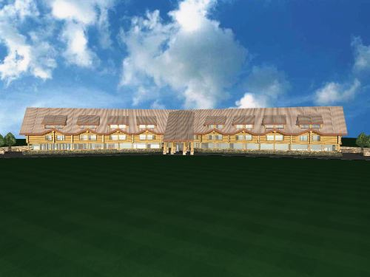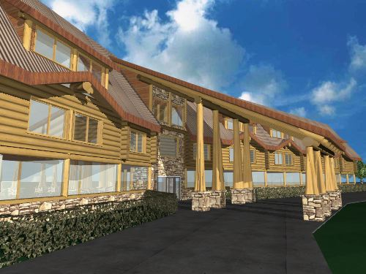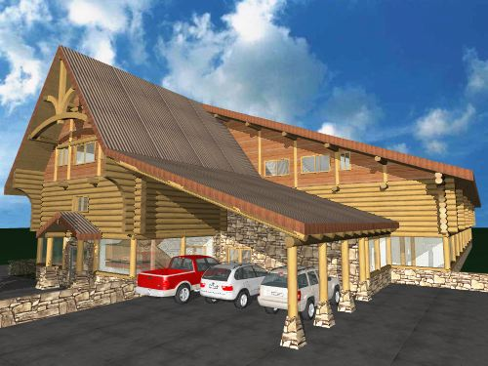
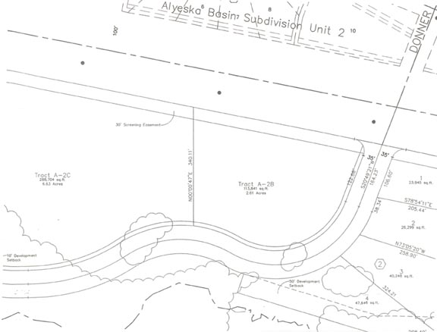

- Agenda Item LUC 0507-03 (Case number S11387-1) Hearing Date July 11, 2005; Petitioner: Glacier City Development, LLC, Jeffrey & Eileen Demain, Girdwood, AK 99587; To subdivide one lot into one different lot with vacation of a 20 foot Telecommunication & Electric easement; Location: East of Crow Creek Road, south of California Creek Way, north of Alyeska Avenue and west of Ski View Road, Girdwood Elementary School Subdivision, Tract E3, located within the SE 1/4 of Section 8, T10N, R2E, S.M., Alaska The above case is a request to vacate (eliminate) a 20-foot wide Telecom & Electrical easement which runs north and south along the west property boundary, about 25-feet in and is the same shape and alignment as the west property boundary. The tract will not be divided, it will remain as one tract of land containing 1.504 acres according to the application plat.

This item may be completed by the date of the meeting but is on the agenda in the event the hearing date at the Planning and Zoning Commission is continued. Unless it is continued petitioner need not be present. Action will be taken as deemed appropriate by the LUC.

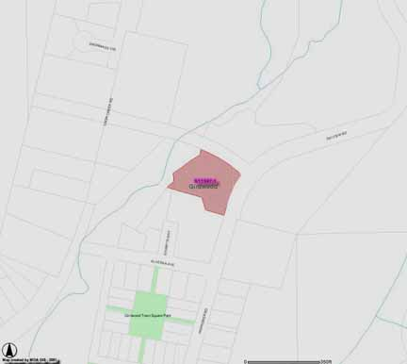

- Agenda Item LUC 0507-04 (Case number S11394-1) Hearing date: Monday, Aug 01, 2005; Petitioner: Anthony Restivo, Girdwood, AK 99587; Representative: Robert ohns, Jr., 1700 Brink Drive, Anchorage, AK 99501, E-Mail: bobjohns@alaska.com; Request: To subdivide one lot into two lots west of Alyeska Highway and south of DeEtte Circle, US Survey 3043, Lot 18 N1/2, located within the SE 1/4 of Section 18, T10N, R2E, S.M., Alaska.

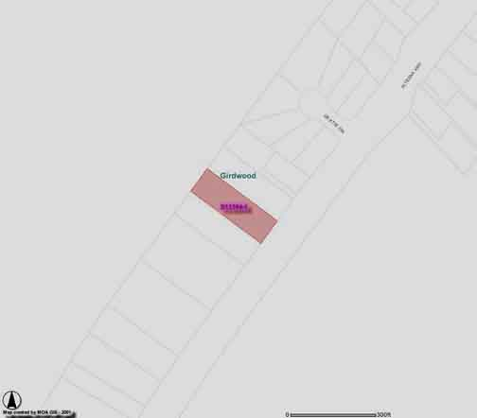

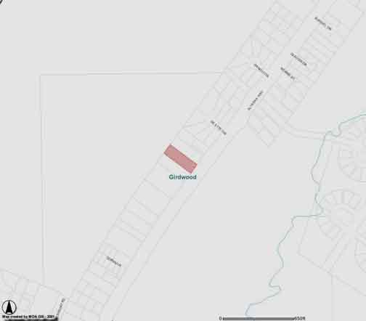

- Agenda Item 0507-05 (Case number 2005-108) Hearing Date: Monday, Sep 12, 2005; Petitioner: Per Bjorn-Roli, PO Box 110903, Anchorage, AK 99511, E-Mail: perbjornroli@aol.com; Request: A conditional use to allow a 12 plex multiple family residential structure in the R-11 zoning district. Alyeska Subdivision, Block 6A, Lot 11A (Now platted as Lot 11B). Located on Garmisch Drive; R-11 Turnagain Arm district.
Reference previous agenda item LUC 0505-09 Platting Case S11375-1 Per Bjorn-Roli To subdivide two lots into two different lots. East of Alyeska Avenue and south of Garmisch Road. Alyeska Subdivision, Block 6A, Lot H1A & I1A, located within the NW1/4 of Section 16, T10N, R2E, S.M., Alaska. Fred Walatka & Associates (Hearing date 5/30/05)
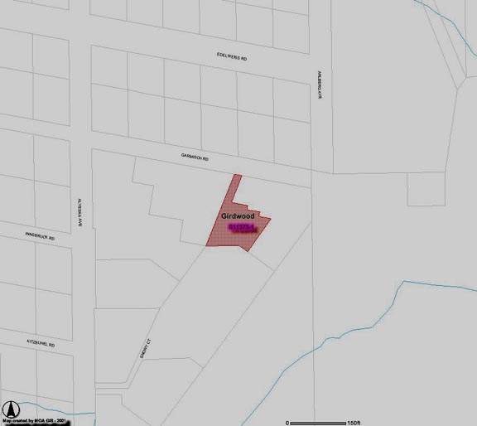

- Agenda Item LUC 0507-06: Alison Rein, arein@fs.fed.us
The Forest Service has applied for an easement from HLB for a trailhead at approx. mile 2.9 (about 1/4 mile downhill from the road into the Mine), on the downhill side of the road. Art Eash told me to present this to Land Use for their approval, then it should get sent on to GBOS. Trailhead would accommodate up to twenty (20) vehicles, have an outhouse (vault toilet) and interpretive / informational signs.
We (USFS) initially planned to build this trailhead on the uphill side of the road- which is still Forest Service Land, but I was not able to fit a road into this side under 12% slope.
From: Alison M Rein [arein@fs.fed.us]
Sent: Friday, June 24, 2005 9:37 AM
To: ron@burson.org; afkes@uaa.alaska.edu; frankcm@muni.org
Subject: agenda item LUC & gird trails:
I'd like to have the following on the agenda's for the July meetings:
Approval/support of grant application for reconstruction of Alyeska Highway Bike Trail, between the Forest Service Driveway and Crow Creek Road.
Background: Girdwood Trails is one of the named trails in the Fiscal Year 2005 Omnibus Appropriations Act sponsored by Senator Stevens. The Act included a section called "Alaska Trails Initiative" with a 4 million dollar allotment. Sixteen named trails or facilities were listed, including "Girdwood Trails" The Girdwood Trails committee developed a prioritized list in December 2003 when another funding opportunity was imminent, and the Alyeska Bike Path improvement was on the top of the list at this time. The pathway has deteriorated over time, due to culvert heaving, cutting and patching to install utilities, and frost heave. Presently many bicyclists are using the roadway shoulder because of the uneven, bumpy condition of the pathway. Grant applications are due in by July 22.
We may further narrow down or prioritize the application in order to be more competitive for an award, and will look at the bike path for the most needy section. If there's any opportunity to get funds from other sources so that the entire pathway could be restored, the unit cost will be lower than doing it in small sections.
I will be present at both meetings to answer any questions regarding this proposal.
I understand recommendations from the 2 committees are forwarded on to GBOS for their consideration, so there would not be time for a resolution from GBOS to be included in our grant application. I hope we can discuss how to have GBOS support included in our grant application.

** End of Notice **
The above agenda may be viewed on the Federation of Community Councils Girdwood web page at http://communitycouncils.org/girdwood/girdwood.html. Additional information will be posted there as it is received.

If you would like to receive Land Use Committee information and notification of meetings by email, please email me at Ron@Burson.org with your request.

*********************** Minutes from Last Meeting ***********************

Land Use Committee
June 14, 2005
Regular Meeting
Black is as posted in agenda and actions are in red
Call to Order: Meeting called to order by Chm Larry Daniels at 7:05 pm.
Announcements:
• Conduct of Meeting: Roberts Rules, informal committee of the whole to extent possible but please go through Chair to speak
• Voting members of the Land Use Committee (LUC) are any person eighteen (18) years of age or older who has been a resident and/or property owner, business owner or designated representative of a non-profit association who has resided in, owned property in, owned a business located in, or operated as a non-profit association for ninety (90) days or longer in Girdwood Valley, and in accordance with the LUC Operating Principles.
• Public work sessions were held on Chapter 9
• Larry Daniels reviewed other upcoming meeting dates
o 6/20 GBOS
o 6/15 Federation of Community Councils at City Hall
o 7/5 Trails Committee (unless rescheduled)
o 7/12 LUC
o 7/18 GBOS
o 7/20 Federation of Community councils at City hall
• Vote to accept for consideration any late agenda items, if any:
- S11387-1 Very recent case regarding vacation of easement. No other information was available so no action was taken. Probably will be an agenda item for next meeting.
• Agenda Item LUC 0506-01: Officer Reports & LUC comments and actions as necessary.
• Chairman’s report
- Nothing to report
• Vice-Chairman’s report
- Nothing to report
• Secretary’s report
- Approval of 5/18/05 LUC meeting minutes Secretary Ellen Twiname stated that wherever Art Eash’s name appeared it should be changed to Robin Ward. Additionally, Agnew Beck should be changed to Chris Beck. With those changes, the minutes from the previous meeting were approved as published. 1) John Gallup 2) Jeff Sherman Approved: Yea 8; Nay 0; Abstain 0
- Announcements: - John Gallup will not be able to attend the July LUC meeting, but he will get someone else to attend in his place.

• Agenda Item LUC 0506-02: Committee Reports
o Title 21, Chapter 9 Work Session Committee Larry Daniels briefed those present on previous meetings and actions taken on Chapter 9.
o The Skate Board Park Committee is considering joining forces with the Playground committee for better use of resources
• Agenda Item LUC 0502-03: (Case Number: 2005-096); Planing & Zoning Commission and Assembly Hearing Date: Wednesday, Jul 20, 2005; Petitioner: Municipality of Anchorage; Detail: AN ORDINANCE AMENDING ANCHORAGE MUNICIPAL CODE TO ADD A NEW CHAPTER 21.09, GIRDWOOD LAND USE REGULATIONS, AMENDING THE ZONING MAP ACCORDINGLY, AND AMENDING CHAPTER 21.40 TO ADD GIRDWOOD USE DISTRICTS.
(old business from February, March, April & May meetings) Tom Nelson, MOA Planning Director, stated there might be an advantage to Girdwood in adopting Chapter 9 of Title 21, the Chapter directed towards Girdwood, in 2005 rather than waiting for the entire the entire new Title 21 to be adopted in 2006 or 2007. Action by the LUC is required to move forward on an adoption of Chapter 9. The LUC’s Chapter 9 Work Session Committee reported to the LUC at the April meeting but due to a request by the Administration, the updated version of Chapter 9 was not available for distribution at the April meeting. Copies were subsequently made available.
Further, the Final Public Hearing Draft of the Girdwood Land Use Regulations is available on the municipal website ("file:///\\\\www.muni.org\\planning\\prj_T21_Girdwood.cfm"). Copies may be picked up at the municipal Planning and Development Center (4700 Bragaw Street, Anchorage--Planning Counter), and copies are also available at the Scott and Wesley Gerrish Library in Girdwood. Be sure to check the web site above for the latest information or changes.
The resolution passed by the LUC at the May 10, 2005 meeting is as follows:
o Motion: In keeping with the deliberative process move forward with the May 18 & 21 Public meetings and then decide at the July LUC meeting how best to move forward and that we be allocated a minimum of 30 days to review the next draft. 1) Lana Johnson 2) Don Johnson (Yea 38; Nay 0; Abstain 13 - Passed)
Text of the letter sent by the GBOS to the Land Use Committer on May 17, 2005 is as follows: On Monday, May 16, 2005, the Girdwood Board of Supervisors ("GBOS") voted unanimously on a resolution to forward the recommendations from the May 18, 2005 and May 21, 2005 work sessions and the May 25,2005 GBOSILUC joint meeting to the Municipality's Planning Department, so that the planning folks can complete the Chapter 9, Title 21 public review draft and remain on their timetable to complete Chapter 9 in 2005.
This resolution is at odds with the portion of the Land Use Committee ("LUC") resolution 0502-03, which sought to defer action on Chapter 9, Title 21 until the July LUC meeting.
Please be advised that the GBOS took this action in the hopes of keeping Chapter 9 on schedule because the GBOS felt, after much discussion, that it is critical to keeping other large projects in Girdwood on schedule. The GBOS felt that the delay of one (1) year in the Title 21 project would be detrimental to these other projects. The GBOS also felt that, in light of all the recent interest in Chapter 9, that it was in the community's best interest to "keep the ball rolling" and to urge the community members to work diligently in the next few weeks to arrive at a draft that would be acceptable to all concerned.
After all the recent discussion, the GBOS feels that the current draft of Chapter 9, Title 21 which is the product of almost four (4) years of effort on the part of the subcommittee, is approaching that "golden mean", and that with a little more effort the community can have a finished draft.
In view of the above information, GBOS Rules and Procedures, LUC Operating Principles and previous action by the LUC and the GBOS, the LUC will consider and take action as deemed appropriate.
John Gallup said that one thing stood out; we need to push for a discount mechanism to bring nonconforming people back into the mainstream without costing them thousands of dollars. We need a group rate and a grace period. Larry Daniels said that all of Anchorage might have the same problem, so the Assembly might have to deal with this as a whole. John said that Anchorage contractors are so against the new Title 21, that Anchorage may never get this far, so Girdwood might be the only group that brings this up.
MOTION: The Girdwood LUC wishes the Assembly to consider some type of grandfather rights for property owners who have improved properties which were constructed or whose plans were approved for construction prior to the passage of Chapter 9 of Title 21. In addition it is requested that Planning & Zoning and the Assembly have an expedited and less costly variance process for Girdwood property owners impacted by the changes brought on by passage of these regulations. 1)John Gallup 2)Kevin McDermott - PASSED (11-0-0)
John Gallup suggested that since all of us were seeing the new June draft for the first time, we spend until 8:45 going over it item by item to make sure all of the suggested changes were incorporated. [This is what we ended up doing for most of the meeting.]
Larry Daniels said that this meeting was so sparsely attended that it doesn't really reflect community views enough for us to recommend this draft on behalf of the community.
HOMEWORK: For the next meeting in July, people should read this new June draft and come in with recommendations for this draft.
Motion: Put GBOS on notice that the LUC may be forwarding additional comments / recommendations on the proposed Chapter 9 of Title 21 for the July 18, 2005 meeting and for the Planning and Zoning hearing on July 20, 2005.
1) Larry Daniels 2) John Gallup Passed: Yea 11; Nay 0; Abstain 0
• Agenda Item LUC 0506-03 (Case number 2005-082) Hearing Date: Monday, Jul 11, 2005; Petitioner: Tim Cabana; Request Detail: A conditional use for parking calculations, landscaping and sign regulations for a hotel. Alpine View Estates Phase 1, Tract A-2C. Located on the south side of the Alyeska Highway, west of Timberline Drive in Girdwood; Legal Desc.: R-11 Turnagain Arm district; Site Address: NHN KAMI WAY. For further information, refer to Agenda Item LUC 0505-10 (Case Number not available) Tim Cabana Project - 50 room hotel on Donner. Although a case number was not available at the time the LUC took with the following action at the May 10, 2005 meeting: Motion: Non-objection to the hotel and shops as presented by Tim Cabana. 1) Barry Kircher 2) Chris Von Imhof (Yea 40; Nay 0; Abstain 6 Passed.
Action will be taken as deemed appropriate by the LUC.
No one was in attendance to present this case. Hearing date is July 11, 2005.
Jeff Sherman opposed passing anything on to the next step in the process without knowing what the thing is. Someone said that the signage would have to comply with current regulations. Ron Burson said that the GBOS passed a resolution that signage had to be approved by the GBOS.
Motion: Pass on to GBOS for their action with no recommendation from LUC.
1) John Gallup 2) Kevin McDermott Passed: Yea 8; Nay 0, Abstain 3
• Agenda Item LUC 0506-04 (Case Number: S11379-1) Hearing Date: Monday, Jun 13, 2005; Petitioner: Kevin McDermott; Representative: Lantech, Inc. / Tom Dreyer;
Request Detail: To subdivide one lot into two lots Northwest of Alyeska Highway (Crow Creek Road); Legal Desc.: US Survey 3044, W99 ft of lot 36, located within the NW 1/4 of Section 17, T10N, R2E, S.M., Alaska.
Kevin McDermott explained his request and stated that even though the hearing date was Monday, June 13, it was a closed meeting and he had not heard what action was taken.
Motion: Approval of establishment of flag lot from lot 36 as presented by Kevin McDermott.
1) John Gallup 2) Jeannie Sherman: Passed: Yea 11; Nay 0; Abstain 0
Motion to adjourn: 1) Daniels 2).McDermott: - PASSED unanimous 8:40 PM

***************************************************************************************************
Miscellaneous Information and Communications Received

*****************************************

From: Allan Tesche [teschea@muni.org]
Sent: Thursday, June 30, 2005 9:34 AM
Subject: Assembly report for meeting of June 28, 2005

Good Morning!

On Tuesday night, the Assembly voted to loan $120,000 to keep Hilltop ski area open, but stalled on a proposed Ethics Code, a bicycle helmet law, restrictions on the Call of the Wild Bar, and a rezone for the old Alaska Seafood Plant.

Read all about it.

Click on my web log for an Assembly report for Tuesday, June 28, 2005. http://teschereport.blogspot.com/

Allan Tesche
Anchorage Assembly, Downtown

*****************************************

From: Community Councils [councils@ak.net]
Sent: Monday, June 27, 2005 8:08 AM
Subject: FW: Anchorage Woodlot Hours

The wood disposal lot hours have been extended, at least for the south Anchorage lot at C and Minnesota. This is an important development because the hours have been very short this season.

The Anchorage Soil & Water Conservation District has extended the hours of operation of the Anchorage Woodlot effective immediately. The new hours are as follows:

Monday through Thursday 9am - 8pm
Friday through Sunday 10am - 6pm

For more information, go to http://www.muni.org/fire1/Woodlots.cfm

Thank you,
Ryan Stencel
Operations Manager
Anchorage Soil & Water Conservation District

Additional information:
Municipal Wood Lots are for the disposal of wood and brush by private homeowners. No stumps, garbage, metal, or construction materials will be allowed. There is no charge for disposal at either the Anchorage or Eagle River Wood Lots.

For garden wastes:
Anchorage Regional Composting Facility
Contact: Pete Kineen 243-8577

Accept wood of any kind, leaves, brush, grass, stable waste.
7895 West End Rd, 3.7 mi. west of Northern Lights Blvd. and Postmark Rd.

Nominal fee charged.

*****************************************

From: Diana Stone Livingston [dstoneliv@livingstonalaska.com]
Sent: Tuesday, June 07, 2005 4:22 PM
Subject: Time for a Thank you

You may or may not have heard that the State Legislature has included the Girdwood Library and Community Center in their recent capital budget awards, for the amount of $1 million.

Our Representative Mike Hawker was the force behind getting our project included; he worked without benefit of Senator Bunde's help because the Senator was away from Juneau on personal business.

Although the Governor could veto any portion of this budget up to June 27th, it would be appropriate to email Rep. Hawker at this time with a line of thanks for his work on behalf of Girdwood.

Rep. Hawker's email address is representative_mike_hawker@legis.state.ak.us

Please send a note of thanks whether or not you originally wrote to Rep. Hawker requesting his support. And, after the budget goes past the veto deadline, send him another note.

This first $1 million is very important because so many of the other potential underwriters of our Library/Community Center project are unwilling to commit their support until someone makes the first move.

Thank you for doing this small, very important thing, and would you please copy me with your thankyou to Rep. Hawker.

Regards, Diana Livingston, Task Force Member


*****************************************


Bird Creek to Girdwood Bike Ride

When: Saturday, July 30th 10 AM to 1 PM

Where: Ribbon cutting ceremony at the New Bird Creek Access Parking Lot (11 mile ride to Girdwood)
or
Decorate your bike at the Bird Point Parking Lot and start there. (6 mile ride to Girdwood)

Finish up at the Glacier District US Forest Service Cabin on Forest Station Road and Alyeska Highway.

Why: Proceeds will benefit community projects sponsored by the Girdwood Rotary Club and because it’s FUN!

Registration: by Mail, to be received by July 18th, at PO Box 1205 Girdwood, AK 99587 - or the day of the event at Bird Creek Access starting point at 9 AM. Please click on one of the following links to open and print out the registration form.
Adobe .PDF Format
Microsoft .doc Format
Rich Text .rtf Format
Pre-register by July 18th for $15 per participant or $40 for a family entry
T-Shirts available for pre-registered riders only
$15/ Adult (S,M,L,XL)
$12/ Child (M, L)
Pick up your shirt at Bird Creek Access day of event from 9 AM until 10 AM.
Mail your completed Registration Form with your check to:
Girdwood Rotary Club
PO Box 1205
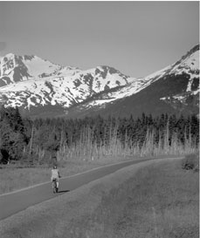
Girdwood, AK 99587
Course Description: Newly Paved multi-use trail parallels Seward Highway and the Turnagain Arm. Some hills, sun exposure, variable wind conditions. Bring water and sunscreen and a big smile!

Enjoy the scenic views of the Turnagain Arm while showing. your support for the community by joining in our Bird Creek to Girdwood Bike Ride. All participants must wear an ANSI / Snell approved helmet at all times - and please leave your canine companion at home! Shuttle Service will be available for drivers only from all access points.

Contact: bird_to_gird@yahoo.com

Bird to Gird Bike Ride Benefits Community projects as coordinated by the Girdwood Rotary Club. Sponsors include:
Girdwood Rotary
Challenge Alaska
Turnagain Arm Health Center
Healthy Futures
Municipality of Anchorage
Department of Transportation
Chugach State Park
Girdwood Ski and Cyclery
Ginny's Personal Training Services
with special permit from United States Forest Service
For more information on this event please email us at bird_to_gird@yahoo.com

