Land Use Committee
June 14, 2005
Order of Business
Call to Order:

Announcements:
- Conduct of Meeting:
  - Roberts Rules, informal committee of the whole to extent possible but please go through Chair to speak
  - Time limits, if necessary
- Announcements
  - public work session
  - Other upcoming meeting dates
    - 6/20 GBOS
    - 6/15 Federation of Community Councils at City Hall
    - 7/5 Trails Committee (unless rescheduled)
    - 7/12 LUC
    - 7/18 GBOS
    - 7/20 Federation of Community councils at City hall

- Vote to accept for consideration any late agenda items, if any:
  - S11387-1 ???
  - Announce Order of Business - Reason for any changes if different than published:

Agenda Item LUC 0506-01: Officer Reports & LUC comments and actions as necessary.
- Chairman’s report

- Vice-Chairman’s report
  - None
- Secretary report
  - Approval of 5/18/05 LUC meeting minutes – see attached

Agenda Item LUC 0506-02: Committee Reports
- Title 21, Chapter 9 Work Session Committee – Larry Daniels, et. al.
- Any other committee reports?

Go to RED Highlighted on next page for agenda items
Girdwood Land Use Committee
Notice of Agenda
for
June 14, 2005 Regular meeting

The following items have been submitted as agenda items for consideration at the June 14, 2005 regular meeting of the Girdwood Land Use Committee.
Voting members of the Land Use Committee (LUC) are any person eighteen (18) years of age or older who has been a resident and/or property owner, business owner or designated representative of a non-profit association who has resided in, owned property in, owned a business located in, or operated as a non-profit association for ninety (90) days or longer in Girdwood Valley, and in accordance with the LUC Operating Principles.

What: Regular meeting of the Girdwood Land Use Committee
Where: Glacier City Hall (next to Little Bears)
Date: June 14, 2005
Time: 7:00 pm

** Effective with the April meeting, Land Use Committee agenda items will be numbered LUC yymm-## (yy = year, mm = month, -## = assigned agenda number for meeting). Items carried over to subsequent meetings are old or unfinished business and will retain their originally assigned number. **

- Agenda Item LUC 0506-01: Officer reports, minutes approval and LUC comments and actions as necessary

- Agenda Item LUC 0506-02: Committee reports;

- Agenda Item LUC 0502-03: (Case Number: 2005-096); Planing & Zoning Commission and Assembly Hearing Date: Wednesday, Jul 20, 2005; Petitioner: Municipality of Anchorage; Detail: AN ORDINANCE AMENDING ANCHORAGE MUNICIPAL CODE TO ADD A NEW CHAPTER 21.09, GIRDWOOD LAND USE REGULATIONS, AMENDING THE ZONING MAP ACCORDINGLY, AND AMENDING CHAPTER 21.40 TO ADD GIRDWOOD USE DISTRICTS.
(old business from February, March, April & May meetings) Tom Nelson, MOA Planning Director, stated there might be an advantage to Girdwood in adopting Chapter 9 of Title 21, the Chapter directed towards Girdwood, in 2005 rather than waiting for the entire the entire new Title 21 to be adopted in 2006 or 2007. Action by the LUC is required to move forward on an adoption of Chapter 9. The LUC’s Chapter 9 Work Session Committee reported to the LUC at the April meeting but due to a request by the Administration, the updated version of Chapter 9 was not available for distribution at the April meeting. Copies were subsequently made available.
Further, the Final Public Hearing Draft of the Girdwood Land Use Regulations is available on the municipal website (www.muni.org/planning/prj_T21_Girdwood.cfm). Copies may be picked up at the municipal Planning and Development Center (4700 Bragaw Street, Anchorage--Planning Counter), and copies are also available at the Scott and Wesley Gerrish Library in Girdwood. Be sure to check the web site above for the latest information or changes.
The resolution passed by the LUC at the May 10, 2005 meeting is as follows:
  - Motion: In keeping with the deliberative process move forward with the May 18 & 21 Public meetings and then decide at the July LUC meeting how best to move forward and that we be allocated a minimum of 30 days to review the next draft. 1) Lana Johnson 2) Don Johnson (Yea 38; Nay 0; Abstain 13 - Passed)
Text of the letter sent by the GBOS to the Land Use Committer on May 17, 2005 is as follows: On Monday, May 16, 2005, the Girdwood Board of Supervisors ("GBOS") voted unanimously on a resolution to forward the recommendations from the May 18, 2005 and May 21, 2005 work sessions and the May 25,2005 GBOSILUC joint meeting to the Municipality's Planning Department, so that the planning folks can complete the Chapter 9, Title 21 public review draft and remain on their timetable to complete Chapter 9 in 2005.

This resolution is at odds with the portion of the Land Use Committee ("LUC") resolution 0502-03, which sought to defer action on Chapter 9, Title 21 until the July LUC meeting.
Please be advised that the GBOS took this action in the hopes of keeping Chapter 9 on schedule because the GBOS felt, after much discussion, that it is critical to keeping other large projects in Girdwood on schedule. The GBOS felt that the delay of one (1) year in the Title 21 project would be detrimental to these other projects. The GBOS also felt that, in light of all the recent interest in Chapter 9, that it was in the community's best interest to "keep the ball rolling" and to urge the community members to work diligently in the next few weeks to arrive at a draft that would be acceptable to all concemed.

After all the recent discussion, the GBOS feels that the current draft of Chapter 9, Title 21 which is the product of almost four (4) years of effort on the part of the subcommittee, is approaching that "golden mean", and that with a little more effort the community can have a finished draft.
In view of the above information, GBOS Rules and Procedures, LUC Operating Principles and previous action by the LUC and the GBOS, the LUC will consider and take action as deemed appropriate.

- Agenda Item LUC 0506-03 (Case number 2005-082) Hearing Date: Monday, Jul 11, 2005; Petitioner: Tim Cabana; Request Detail: A conditional use for parking calculations, landscaping and sign regulations for a hotel. Alpine View Estates Phase 1, Tract A-2C. Located on the south side of the Alyeska Highway, west of Timberline Drive in Girdwood; Legal Desc.: R-11 Turnagain Arm district; Site Address: NHN KAMI WAY. For further information, refer to Agenda Item LUC 0505-10 (Case Number not available) Tim Cabana Project - 50 room hotel on Donner. Although a case number was not available at the time the LUC took with the following action at the May 10, 2005 meeting: Motion: Non-objection to the hotel and shops as presented by Tim Cabana. 1) Barry Kircher 2) Chris Von Imhof (Yea 40; Nay 0; Abstain 6 – Passed.
Action will be taken as deemed appropriate by the LUC.
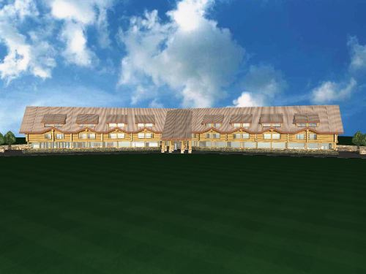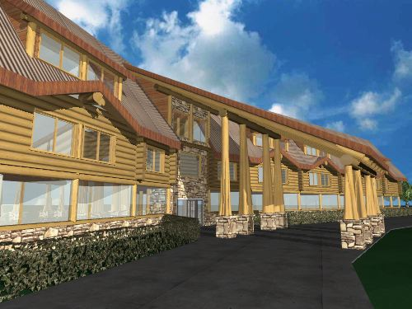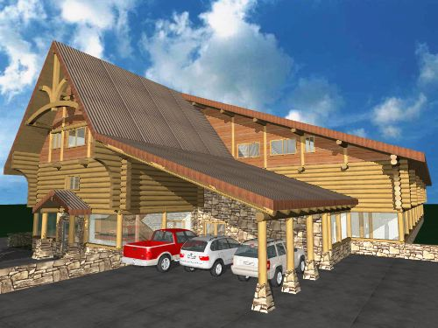
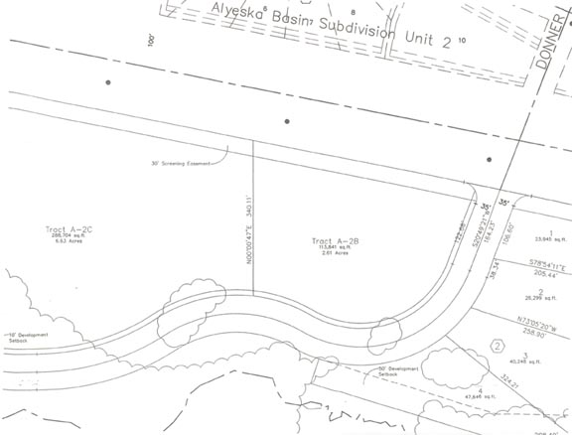

- Agenda Item LUC 0506-04 (Case Number: S11379-1) Hearing Date: Monday, Jun 13, 2005; Petitioner: Kevin McDermott; Representative: Lantech, Inc. / Tom Dreyer;
Request Detail: To subdivide one lot into two lots Northwest of Alyeska Highway (Crow Creek Road); Legal Desc.: US Survey 3044, W99 ft of lot 36, located within the NW 1/4 of Section 17, T10N, R2E, S.M., Alaska.

** End of Notice **
The above agenda may be viewed on the Federation of Community Councils Girdwood web page at http://communitycouncils.org/girdwood/girdwood.html. Additional information will be posted there as it is received.

If you would like to receive Land Use Committee information and notification of meetings by email, please email me at Ron@Burson.org with your request.

***************************************************************
Girdwood Land Use Committee
05/10/05 Meeting Notes
Ellen Twiname, Secretary
7:05 PM - Larry Daniels called the meeting to order. 69 people signed in.
Announcements
Larry Daniels made the following announcements:
Conduct of Meeting: – Roberts Rules modified as needed.
Crow Creek Neighborhood Plan - There is a meeting coming up sometime in the next month, but we don’t yet know when.
Upcoming meeting dates:
5/16 GBOS
5/18 Federation of Community Councils
6/7 Trails Committee
6/14 LUC
6/15 Federation of Community Councils
6/20 GBOS

Late Agenda Items
Tim Cabana project added.
Approval of Minutes
Motion: To approve the meeting minutes for April: 1.Twiname/2.Powers - PASSED (5-0-0)
Agenda Item LUC 0502-03
Chapter 21.09

Motion: We go forward with the workshops to allow community additional time to review the current draft, then at the May 24 LUC/GBOS joint meeting we discuss the schedule for adoption. 1. Jonas / 2. Tryck - NOT PASSED (18-36-0)

Motion: In keeping with the deliberative process move forward with the May 18 & 21 meetings and then decide at the July LUC meeting how best to move forward. 1. Lana Johnson /2. Don Johnson

Friendly amendment: and that we be allocated a minimum of 30 days to review the next draft. 1. Lana Johnson / 2. Don Johnson - PASSED (44-4-7)

Entire motion restated: In keeping with the deliberative process move forward with the May 18 & 21 meetings and then decide at the July LUC meeting how best to move forward and that we be allocated a minimum of 30 days to review the next draft. 1. Lana Johnson / 2. Don Johnson - PASSED (38-0-13)

Points raised during discussion:

Larry Daniels introduced Erica McConnell standing in for Tom Nelson. He also explained the window of opportunity for having the Muni concentrate on Chapter 9 separately from the rest of Title 21. For now the Planning Dept. is asking us to vote on their schedule, not the Chapter 9 draft, just the schedule.

Julie Jonas: The Chap. 9 Subcommittee is ready to go forward unanimously with this schedule. We now have the April 2005 draft, and the only part changed by the administration is the purple area plus a note that purple area will be studied further and perhaps changed in 2006. The document is very thick, and people might fear thickness and change, but in this case, change is good.

Per Bjorn Roli: This draft came from the Subcommittee. The Subcommittee was not unanimous, but they did all agree that everyone should read it, and digest it. Would favor a mailing to all property owners to tell them about the workshops, so everyone goes. Nothing bad will happen to Girdwood if you take a year to digest this.

Jeff Sherman: Out of 100 pages, 12 apply to you. Right now we have R11. Even if you are zoned commercial, you have to go through many agencies. Now if your property is zoned commercial, the process will be more streamlined. That will be the greatest benefit. These two workshops are very important. The Subcommittee will have a chance to explain the reasons for all of their decisions.

Larry Daniels: We scheduled the 18th & 21st for workshops. The purpose is to get more familiar with how the documents are put together and how they affect you. The meeting on the 24th is to let the Planning Dept. know of any changes the community wants.

Gary Kircher: The schedule is too compressed. Put it off until the fall.

Diana Stone Livingston: This document affects all property owners. More effort needs to be taken to get drafts into the hands of all property owners. Marry in haste, repent in leisure. In favor of continuing with schedule of workshops, but now one goes to meetings in the summer. Stretch the timeline out.

Tim Cabana: This will have a large impact on his business.

John Gallup: Nobody attends meetings unless someone calls them and says get your butt down here. The document has been out for almost a year. The mayor's change was small. It takes three hours to read the draft thoroughly. Let's hold our feet to the fire and proceed.

Joe Hanson: It took years to get this document this far. More time won't matter. People were surprised about this. Freedoms are taken away.

Diane Powers: Thanks to everyone who worked on this so far. People who don't go to meetings, how can they get their comments in?

Erica: It's on the muni website, and you can email your comments.

Julie Jonas: There are at least 50 people here. They all know about the website and there is a box of hard copies here for distribution.

John Gallup: Everyone take a copy home and read it from cover to cover so we can be productive.

Diana Stone Livingston: By design the LUC is here to give a voice to everyone so at the joint meeting the vote will be from the LUC, and then the GBOS officers.

Larry Daniels: It will be like usual, the people vote, the LUC recommends the vote to the GBOS, then the GBOS votes.

Lana: Why would we want to hurry like this. I just lost my hot tub.

Brookes Chandelar: Julie's motion only said we'd discuss the schedule. Why don't we just adopt a schedule.

Joe Hanson: Will everyone get a copy of this?

Erica: We'll notify all property owners as required by code.

John Gallup: Get it from the muni web site. Use your own ink from your own printer and save the muni $6.

Per: The subcommittee got its job done. Now it's up to the LUC.

Bob Persons: People are going to react strongly to these outrageous proposals like being restricted to building on 40% of your property.

Brookes: Haven't heard a commitment from the Muni that there will be another draft.

Agenda Item LUC 0504-08
Proposed MOA Large Animal Ordinance
no action

Discussion points:
Jake Thompson: doesn't know exactly where ordinance stands right now
John Gallup: will it affect you?
Jake: no
John: keep me posted
Jake: The horse community has had meetings and given its input.

Agenda Item LUC 0505-09
Per Bjorn-Roli’s lot subdivision
Motion: Non-objection to Per’s lot change 1.Cabana/2.Gallup - PASSED (50-0-1)

Agenda Item LUC 0505-11
Airport Master Plan Draft EIS
Motion: Non-objection to the draft environmental assessment 1.Livingston/2.Gallup - PASSED (30-0-11)

Discussion Points:
John McPherson: presented some proposed airport improvements on website for public review & comment. Improvements include adding riprap to halt erosion, make airport longer to add safety space, and lower some power lines.

Joe Hanson: why not bury the power line?

John: don't know

Diana Stone Livingston: Don't see a trail included on the 5 or 20 year plan.

John: It's not in the proposal. It's described in the master plan but not proposed. There is an opportunity to make comments. The comments period closes on the 13th. It's at girdwoodairport.com.

Agenda Item LUC 0505-10
Tim Cabana Project - 50 room hotel on Donner
Motion: Non-objection to the hotel and shops as presented by Tim Cabana 1.Kircher/2.Von Imhof - PASSED (40-0-6)

Discussion points:
Chris Von Imhof: Wish you much luck, we need a place when Alyeska overbooks, the design looks very nice.

Tim Cabana: A liquor license is not automatic, it has to be applied for. It won't be a transfer, it will be an original one. This project will be in front of the LUC again later in the process when it's time for that.

Agenda Item LUC 0505-12
Crow Creek Road Neighborhood Plan
Motion: move that LUC sends forward to GBOS non-objection the Crow Creek Neighborhood Plan as it is amended from the draft in March. 1.Stone-Livingston/2.Wilson PASSED (18-3-4)

Agnew:Beck (Chris Beck) After the meetings and workshops held to figure out how to do a development that works with the neighborhood and the land, we came back with these modifications and recommendations. [He then read them aloud exactly as they were written on the handout.]

Justin: What about the volume of traffic getting added to Crow Creek Rd.

Chris Beck: Once Crow Creek Rd. is upgraded, it will handle the new capacity.

Joe Hansen: Will heritage land bank put in all the new utilities? Who will finance that?

Art Eash: HLB will partner with developers and they will get construction bonds.

Per Bjorn Roli: It looks like an expensive development. Will there be an economic matrix done?

Art Eash: Yes, in the master plan.

Jeff: Wasn't Alyeska Basin 100% sold as empty lots? An empty lot is low income housing.

Chris Beck: 10% of the development will be sold as empty lots.

Jeff: Everybody in this room who bought and empty lot and built their own house, raise your hand.

[many hands raised]

Jeff: More than 10% in this room bought lots and built their own house.

Jake: Where are the utilities going on Crow Creek Road?

Art Eash showed him on the map.

Art Eash: They don't know if the road is in the right of way until a survey is done, then they'll know where to put stuff.

Kathy: This density is so intense, we are doubling Girdwood density and putting it all on Crow Creek Road. The road is really busy already.

Joe: Have core samples been done?

Chris Beck: Not many yet.

Tim: Doesn't want the city to get into the development business. It's better to sell to individuals.

Art Eash: HLB will partner with developers.

Brookes: Did you include dedicated park land and dedicated trails?

Chris Beck: Yes, there are trails and buffers that will remain in public ownership.

Someone: We need another way out of this valley. It's too high density.

Keith: How to get land into the hands of individuals without incurring development costs? Broaden your scope. Auction? Lottery?

How will you evaluate developers to make sure they're good?

Art Eash: don't know, she might not be director in two years.

Joe Hanson: A lottery. Any compelling reason to develop this area first?

Chris Beck: It's proximity to existing development.

Diane: The density won't change. It's population that will change. 1500 new people. Would like to see more lots for individuals.

Justin: can you restrict the number of lots people can buy?

Art Eash: That's not legal.

What about restricting development to 350 units?

Chris Beck: Then you risk killing the project because it won't cover infrastructure costs.

Kathy: What will it do to land values?

Chris Beck: Gradually add land to the market to relieve pressure so it doesn't get too expensive.

Motion to adjourn - PASSED 10:30 PM

