Girdwood Land Use Committee
Notice of Agenda
for
May 10, 2005 Regular meeting
Revised (1) - 7/28/2026 4:39 PM

The following items have been submitted as agenda items for consideration at the May 10, 2005 regular meeting of the Girdwood Land Use Committee.
Voting members of the Land Use Committee (LUC) are any person eighteen (18) years of age or older who has been a resident and/or property owner, business owner or designated representative of a non-profit association who has resided in, owned property in, owned a business located in, or operated as a non-profit association for ninety (90) days or longer in Girdwood Valley.

What: Regular meeting of the Girdwood Land Use Committee
Where: Glacier City Hall (next to Little Bears)
Date: May 10, 2005
Time: 7:00 pm

** Effective with the April meeting, Land Use Committee agenda items will be numbered LUC yymm-## (yy = year, mm = month, -## = assigned agenda number for meeting). Items carried over to subsequent meetings are old or unfinished business and will retain their originally assigned number. **

- Agenda Item LUC 0505-01: Officer reports, minutes approval and LUC comments and actions as necessary

- Agenda Item LUC 0505-02: Committee reports;

- Agenda Item LUC 0502-03: (old business from February, March & April meetings) Tom Nelson, MOA Planning Director, has stated there might be an advantage to Girdwood in adopting Chapter 9 of Title 21, the Chapter directed towards Girdwood, in 2005 rather than waiting for the entire the entire new Title 21 to be adopted in 2006 or 2007. Action by the LUC is required to move forward on an adoption of Chapter 9. The LUC’s Chapter 9 Work Session Committee reported to the LUC at the April meeting but due to a request by the Administration, the updated version of Chapter 9 was not available for distribution at the April meeting. Copies have now been made available and the LUC will take action as they deem appropriate on a recommendation of Chapter 9. The resolution passed by the LUC at the April 12, 2005 meeting is as follows:
  - LUC April 12 resolution: “Motion: that LUC make a report to GBOS about what transpired, that the subcommittee was ready to move forward, but the administration delayed us. And that the LUC urge the GBOS to urge the administration to withdraw the stay and move forward with the process. 1.Jonas/2.Gallup&Daily - PASSED (16-3-0)”
- Agenda Item LUC 0504-08: Case 2004-137 Proposed MOA Large Animal Ordinance changes (scheduled hearing date is May 9th, 2005) (motion to consider failed at April meeting due to no second)

- Agenda Item LUC 0505-09 Platting Case S11375-1 Per Bjorn-Roli To subdivide two lots into two different lots. East of Alyeska Avenue and south of Garmisch Road. Alyeska Subdivision, Block 6A, Lot H1A & I1A, located within the NW1/4 of Section 16, T10N, R2E, S.M., Alaska. Fred Walatka & Associates (Hearing date 5/30/05)
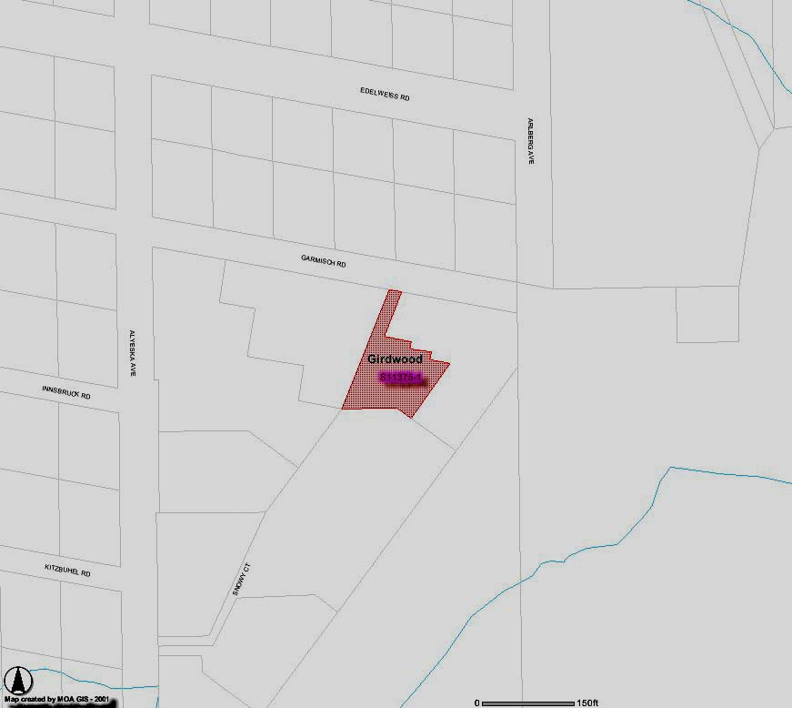
- Agenda Item LUC 0505-10 Airport Master Plan Draft EIS

- Agenda Item LUC 0505-11 Crow Creek Road Neighborhood Plan - Agnew-Beck

** End of Notice **
The above agenda may be viewed on the Federation of Community Councils Girdwood web page at http://communitycouncils.org/girdwood/girdwood.html. Additional information will be posted there as it is received.

If you would like to receive Land Use Committee information and notification of meetings by email, please email me at Ron@Burson.org with your request.

***************************************************************

Girdwood Land Use Committee
04/12/05 Meeting Minutes

7:05 PM - Larry Daniels called the meeting to order. 18 present at beginning, 24 signed in by the end.

Announcements
Larry Daniels made the following announcements:
- Conduct of Meeting: Roberts Rules
- Crow Creek Neighborhood Plan - There is a meeting coming up sometime in the next month, but we don’t yet know when.
- Title 21, Chapter 9 - There will be public work sessions on April 26 and April 30 at the Alyeska day lodge, time TBA.
- Other upcoming meeting dates:
  - 4/18 GBOS
  - 4/20 Federation of Community Councils
  - 5/3 Trails Committee
  - 5/10 LUC
- Upcoming fundraising events:
  - 4/15 Turnagain Arm Health Center Wine Tasting and Auction
  - 4/17 Avalanche Express

Late Agenda Items
none

Chairman’s report
The letter of support for the Library was sent.

Vice Chairman’s Report
The announcements will be posted on the FCC web page

Approval of Minutes
Motion: To approve the meeting minutes for March. 1.Gallup/2.Daily - PASSED (18-0-0)

Committee Reports
- Ron Burson from the Skateboard Park Committee reported that this month’s skateboard park meeting is cancelled. Also, surveys will be coming in the mail this week. Please fill them out.

- Larry Daniels restated last month’s Title 21 Chapter 9 resolution [Motion: Move that we have a draft ready for the community to review at the next LUC meeting and at that time make a decision on the schedule for adoption.] and said Julie would give us an update.

Agenda Item LUC 0502-03
- Julie Jonas reported that the subcommittee has concluded that the draft is ready to go forward. All seven people on the subcommittee worked 20 hours each on this since the last meeting. The subcommittee is made up of broad spectrum of the community, with different interests represented. The following people indicated they were on the committee.
  - Larry Daniels representing Alyeska Resort
  - Julie Jonas was on the GBOS when this started nine years ago, now represents citizens and conservation
  - George Hanson representing Old Girdwood
  - Jeff & Jeannie Sherman representing business
  - Per Bjorn Roli representing 2nd property owners
  - Matt Berman
  - Craig Schubert representing Crow Creek Road
  - George McCoy no longer on the committee
  - All supported the Girdwood Area Plan.
- They resolved to hold two public workshops, and will bring 100 copies to the library for people to read so they can be informed for the workshops. At the workshops, the committee will explain the compromises they made. For example, Girdwood has an aviation district, and it’s had dog kennels in it since way back, so the dog kennels had to be grandfathered in. Then we can adopt a schedule for moving the plan forward. Julie said this is just an update, and no action is required from the LUC at this time. She then read aloud to us some comments emailed to her by Jeff & Jeannie.

- Tom Nelson from the Muni then announced that he didn’t bring the new documents tonight. The administration decided they want an extra month to study what’s going on in the Glacier/Winner Creek areas, to make sure Chapter 9 isn’t inconsistent with the Girdwood Area Plan. This will delay us going forward for a month. One option is to go forward with the exception of the area of resort development. The administration will have more time to focus on this now that the convention center is on its way.

- John Gallup asked does that mean there is no draft to review. Does this mean we should just tread water for now?

- Tom: Yes

- Per Bjorn Roli said he’s a strong believer in property rights, and feels that Chapter 9 will take some freedoms away. The committee had to make many compromises. So everyone must study this carefully and pay attention to how it affects your own property. The committee did its best.

- George Hanson thanked Tom for all his work. Said the committee was very diverse with good representation. He said to urge your neighbors to read this document.

- Larry Daniels said it’s important to identify the specific requirements for getting projects done. He spent many years pushing the hotel through. The current proposed conditions are a step forward for the development community, but many things haven’t been touched on yet. He’s pleased to see this administration taking steps to unify everything into one planning process. Lots of time and energy went into this. The committee got very specific.

- Julie asked other committee members who couldn’t be at the meeting if they wanted her to make comments for them. She said Matt Berman said he wants to go ahead and wants the public to understand the building to lot ratios and that these regulations can’t be used to change the Girdwood Area Plan.

- John Gallup asked if all this meant the meetings on April 26 and 30 are suspended then.

- Larry said yes, we got ahead of ourselves.

- Motion: to commend the Title 21 Committee for all their hard work 1.Burson/2.Gallup PASSED - (unanimous)

- Larry said to also include commending the Muni staff as a friendly amendment.

- Julie said she’s not done yet. She is not happy about the news to delay this more, for the administration to say half an hour before the meeting that they want to delay this more because of another project. Delay is not good.

- Larry said that when the Girdwood Area Plan was made 12 years ago, the Glacier/Winner Creek portion was very crude. Better mapping exists now, so its good to study it now.

- Ginny Grupp asked will this one month delay make it so we can’t stick to the tight schedule for getting Chapter 9 passed.

- Tom said yes, there is a chance the assembly vote could be delayed for months. The assembly schedule is very tight. It’s going to be a challenge. Not an easy decision for the administration. It may be in our best interest for everything (Chapter 9 and Title 21) to go forward together.

- George Hanson said it’s still in the public process.

- John Gallup said there’s lots for the public to read.

- Larry said if there’s no action to take tonight, we need a motion to table this until the next meeting.

- Motion: In the interest of moving it forward, I move that LUC make a report to GBOS about what transpired, that the subcommittee was ready to move forward, but the administration delayed us.

- Per wanted to add to the motion to encourage the city to get it right. Speed the process up or slow it down, but get it right. The golf course took 15 years, and then it disappeared. GBOS should encourage city officials to get this right.

- Erin Bashaw said have GBOS request the administration to move the documents forward as is and not stop the process, since we have a commentary period anyway, they can study the document at the same time as us, and we can all add changes during the commentary period.

- John Gallup seconds the motion and wants to add that the LUC recommends that the GBOS recommends the administration not to stop the process.

- Tom said most of the document doesn’t affect the Glacier Winner Creek area. He didn’t bring any documents to the meeting tonight. The administration told him not to.

- Julie said we are perturbed. The report to GBOS should be that we are not happy about the delay, so we should recommend that we would like the documents to be distributed anyway as is. It’s just a draft anyway, so it can be changed.

- Larry doesn’t want us to say “perturbed.”

- Ron recommends adding a cover letter stating that the Glacier/Winner Creek area is still under consideration.

- Motion: that LUC make a report to GBOS about what transpired, that the subcommittee was ready to move forward, but the administration delayed us. And that LUC urge the GBOS to urge the administration to withdraw the stay and move forward with the process. 1.Jonas/2.Gallup&Daily - PASSED (16-3-0)

Agenda Item LUC 0504-06
no recommendation

Agenda Item LUC 0504-07
Any sale of alcohol for catering purposes at fund raisers shouldn’t require you to go through some kind of cumbersome muni process to get a permit. Larry said we should pass this one, because of that beer garden at the forest fair that’s been going on for years. This is a case of the government bringing the code into compliance with common practice.
Motion: to approve this ordinance 1.Gallup/2.Daily - PASSED (18-0-0)

Agenda Item LUC 0504-08
Currently, if the primary use for a lot is a house, then the secondary use should be smaller. But if you have a horse, then your barn is frequently bigger than your house. This is mostly a Hillside issue. It allows you to have a bigger structure for your horse, if you comply with certain lot sizes, building ratios, and setbacks. It also limits the number of horses you can have before you are considered a commercial operation.
Motion: to approve this ordinance 1.Burson... motion dies for lack of a second.
Erin suggested asking the two horse owning Girdwoodians who weren’t at the meeting if they had an opinion. Larry agreed to call them on the phone.

Agenda Item LUC 0504-03
Proponents didn’t show

Agenda Item LUC 0504-04
Steve Halverson from the Girdwood Church showed everyone the new site plan for their church building project. They want to start building the gravel pad and foundation work in May. They will use mostly volunteers, and everyone is welcome to come and help.
Motion: to approve the church site plan 1.Gallup/2.Daily - PASSED (18-0-0)

Agenda Item LUC 0504-05
Proponents didn’t show, forward to GBOS with no comment.

Motion to adjourn 1.Daniels/2.Gallup - PASSED 8:40 PM

