Governor Dunleavy released his FY2022 Budget plan on Friday, December 11, 2020.
The FY22 budget was developed in cooperation with all state agencies and reflects a total reduction of $294.6 million (UGF), achieved by efficiencies, modernizations, and better delivery of government services.
- The Governor plans to overdraw the Alaska Permanent Fund earnings by more than two times the amount allowed by current state law. He plans to do this to pay for state government and two PFD payouts, totaling nearly $5,000
The Governor has funded these specific areas:
- Funding the rest of the 2020 PFD - $1,916 per eligible Alaskan
- $4 million to address the sexual assault case backlog
- $26 million to fisheries, wildlife, and resource projects
- $350 million to go toward infrastructure projects across the state
- Prioritizes Alaskans by increasing funding for public safety by $13.5 million
- Funds the Alaska Psychiatric Institute to operate at full capacity
- Restores school construction financing to FY20 level

Funding was reduced for the following:
- $35 million Medicaid
- $21 million Public education
- $13 million on highways, aviation, and transportation facilities
- $20 million to University of Alaska

COVID-19: Relief Legislation
Congressional and White House negotiators have reached a deal on a $900 billion COVID-19 relief package.
- $300-per-week federal boost to state unemployment insurance for 11 weeks.
- $600 stimulus checks for Americans earning less than $75,000. ($166 billion)
- A renewed Paycheck Protection Program.
- Extending eviction moratoriums for renters for an unspecified amount of time.

COVID-19: Vaccine
The CDC Advisory Committee on Immunization Practices recommended that states prioritize Americans over the age of 75 and essential frontline workers for the COVID-19 vaccine.
- Essential frontline workers include grocery store employees and teachers.

The FDA has approved another COVID-19 vaccine for use in the U.S.

- The vaccine was developed by Moderna and the National Institutes of Health.
- The data suggests that the Moderna vaccine is 94% effective.
- 5.9 million doses are being shipped to locations across the country.
- The vaccine requires 2 doses spaced several weeks apart.

Doses of the Pfizer-BioNTech COVID-19 vaccine are being shipped to all 50 states.
- On Dec. 11, the FDA approved an emergency use authorization for the vaccine.
- 2.9 million doses of the Pfizer vaccine have been delivered.

Analysis by the FDA shows the Pfizer/BioNTech COVID-19 vaccine to be 94.8% effective.

New clinical data suggest the AstraZeneca-University of Oxford COVID-19 vaccine is 70% effective.

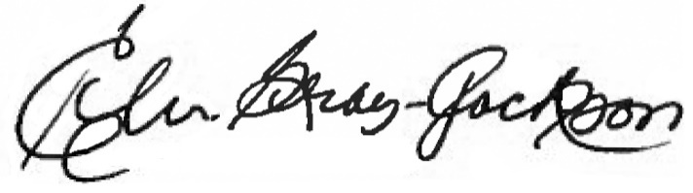
If you are not receiving my monthly newsletter, and interested, please let me know.
Interim: 907-269-0174
Session: 907-465-4930
Email: Keith.Bauguess@akleg.gov or Besse.Odom@akleg.gov

